
L. J. Institute of Computer Application
L. J. University

Master of Computer Application

3rd Semester

Project Name :-
CarZen: Car Selling, Buying, Service System

Submitted To:
Mrs. Dharmi Doshi

Submitted By:
Boghara Aayush M Roll No: E01 25004401110004
Chudasama Vishal B Roll No: E02 25004401110069
Sakariya Pinak B Roll No: E06 25004401110067

Introduction

1.1 Problem Definition
The existing process of buying, selling, and servicing cars is often dependent on manual searches, individual dealers, classified advertisements, and personal estimation of vehicle prices. Buyers may find it difficult to determine whether a car is fairly priced, while sellers may not know the appropriate resale value of their vehicle.
There is also a lack of an integrated platform that combines car buying, car selling, vehicle service information, and price prediction in a single system.
The proposed CarZen system aims to develop an integrated vehicle marketplace and management platform that allows users to list cars for sale, search and filter available cars, place purchase orders and pay online or in cash, book vehicle services, and estimate the expected price of a vehicle using a machine-learning-based prediction system.
The frontend is developed using Flutter. The backend is developed using Python and FastAPI (with SQLAlchemy), while MySQL stores user, vehicle, listing, order, payment, service and prediction-related information.

1.2 Objective of the New System
The main objective is to develop an integrated platform for car buying, selling, reselling, servicing and price prediction.
- Provide a platform for users to buy and sell new or used cars.
- Allow sellers to create and manage car listings.
- Allow buyers to search and filter cars according to their requirements.
- Provide detailed information about available vehicles.
- Support reselling by providing resale listings that record the number of previous owners and the ownership type of the vehicle.
- Provide vehicle servicing: a service catalogue, online service booking, invoices and service history.
- Predict the estimated price of a car using machine learning.
- Store system data securely and consistently using MySQL.
- Provide REST APIs using FastAPI for communication with the Flutter frontend.
- Support online payment (Razorpay) and cash payment for car orders and service bills.
- Provide an admin module for managing users, cars, listings, orders, transactions, services, reviews, reports and system data.
- Reduce the difficulty of estimating the market value of used cars.
- Improve transparency between buyers and sellers.

1.3 Core Components
Component | Description
User Management | Registration, login, JWT authentication, profile management, saved addresses, contact preferences and role-based access (user / admin).
Car Management | Brand-model-variant catalogue, vehicle attributes, photos and features, and admin approval of cars.
Car Selling Module | Create, update, publish, unpublish and remove car listings; track listing status, views, inquiries and orders.
Car Buying/Search Module | Search, filter and sort listings; view vehicle details; favourites; inquiries and messages; purchase orders.
Reselling Module | Resale listings with owner count and ownership type of the car.
Car Service Module | Service catalogue, service requests (book, schedule, complete), invoice PDF, payment and service history.
Price Prediction Module | Estimate the expected price of a car with a trained XGBoost regression model and keep the prediction history.
Admin Module | Approve or reject cars, moderate listings, and manage users, orders, transactions, services, reviews and reports.
FastAPI Backend | RESTful APIs with JWT authentication connecting Flutter, business logic, database and prediction services.
MySQL Database | Primary relational database for structured application data (SQLAlchemy ORM, Alembic migrations).
Order & Payment Module | Purchase orders, Razorpay online payment with signature verification, cash payment confirmation and transaction records.
Reviews, Reports & Notifications | Ratings and reviews of cars, reporting of suspicious listings, and in-app notifications for important events.

1.4 Project Profile
Attribute | Specification
Project Name | CarZen: Car Selling, Buying, Service System (with Reselling and Price Prediction)
Project Type | Cross-platform application / marketplace platform
Domain | Automobile / E-Commerce / Machine Learning
Frontend | Flutter (Dart)
Backend Language | Python
Backend Framework | FastAPI (with SQLAlchemy ORM and Pydantic)
Database | MySQL
API Architecture | REST API
Prediction | Machine Learning (XGBoost regression model)
Authentication | JWT access tokens, bcrypt password hashing, role-based access
Payments | Razorpay (online) and cash
Main Users | Users (acting as buyers, sellers and car owners) and Administrator
Main Purpose | Car buying, selling, reselling, service management and price prediction

1.5 Need of the New System
- Difficulty in determining the correct car price: users may not know the market value of a used vehicle.
- Lack of centralized information: car information, selling information and service records may be distributed across different sources.
- Manual price estimation: prices are often estimated from personal experience rather than a consistent data-driven method.
- Difficulty in finding suitable cars: buyers need efficient search and filtering.
- Limited vehicle history information: previous ownership and service information may not be easily available.
- Lack of integrated service management: service information is often maintained separately.
- Need for an organized used-car workflow: buying and reselling activities benefit from a centralized platform.
- Need for data-driven prediction: machine learning can estimate price from historical and current vehicle attributes.

1.6 Scope of the New System
Scope Area | Included Functions
Buyer Scope | Registration/login; search and filtering; vehicle details; favourites; inquiries and messages; purchase orders; online/cash payment; reviews; expected price.
Seller Scope | Add car with images and features; admin approval; create and publish listing; asking price and negotiability; update/remove listing; manage inquiries and orders.
Reselling Scope | Resale listings; owner count and ownership type; resale price estimate.
Service Scope | Browse service catalogue; book service for own car; track request status; pay online or in cash; invoice; service history.
Prediction Scope | Use car name, year, kilometres driven, fuel, seller type, transmission, owner type, mileage, engine, power and seats to estimate the expected price.
Admin Scope | Manage users, cars, listings, orders, transactions, service catalogue and requests, reviews, reported content and system activity.

Advantages and Limitations of the Proposed System
Advantages
- Provides a single platform for car buying, selling and reselling.
- Makes it easier to search and filter vehicles.
- Helps users estimate the value of a car.
- Maintains vehicle, owner-count and service history information.
- Provides secure and structured data management using MySQL.
- Helps buyers and sellers make better pricing and purchasing decisions.
- Supports online (Razorpay) and cash payments with order and transaction records.
Limitations
- Prediction accuracy depends on the quality of available data.
- Predicted price may differ from the actual market price.
- Incorrect vehicle information can affect the prediction result.
- Price prediction is available only for car names present in the training dataset.
- The system requires a reliable internet connection.
- Service and prediction features may have limited coverage during the initial implementation.

1.8 Proposed Time Line Chart
Phase | Activities | Duration | Progress
Phase 1 | Requirement Analysis | Week 1 | ✓
Phase 2 | System Analysis and Planning | Week 2 | ✓
Phase 3 | Database Design using MySQL | Week 3 | ✓
Phase 4 | System and API Design | Week 4 | ✓
Phase 5 | User and Authentication Module | Week 5 | ✓
Phase 6 | Car Buying Module | Week 6 | ✓
Phase 7 | Car Selling Module | Week 7 | ✓
Phase 8 | Car Service Module | Week 8 | ✓
Phase 9 | Dataset Preparation and ML Model | Week 9 | ✓
Phase 10 | Price Prediction Integration | Week 10 | ✓
Phase 11 | Testing and Bug Fixing | Week 11 | ✓
Phase 12 | Final Documentation and Deployment | Week 12

1.9 Targeted Users
User Type | Main Purpose / Responsibilities
Buyers | Search for and purchase new or used cars; view details and predicted value; send inquiries; place orders and pay.
Sellers | Add cars, list vehicles, set prices, update listings and manage inquiries, orders and selling status.
Car Owners | Add their cars, book services, view service history and find the expected value.
Workshop Service | Service requests are accepted, scheduled, started and completed by the administrator; completed work is saved as service records and invoices.
Administrator | Manage users, vehicles, listings, services, prediction records and overall system operations.

2. Requirement Determination and Analysis

2.1 Requirement Determination
Requirement determination identifies the main requirements needed to develop and operate the CarZen – Car Selling, Buying, Service & Price Prediction System.
The major requirements are:
Functional Requirements
- User registration and login.
- User profile management and authentication.
- Add, update and delete car information.
- Create and manage car listings.
- Search and filter available cars.
- View detailed vehicle information.
- Manage favourites and inquiries.
- Maintain owner count and ownership type of vehicles.
- Book vehicle services and maintain service records and history.
- Place purchase orders and pay online or in cash.
- Submit reviews and report suspicious listings.
- Send in-app notifications for important events.
- Predict estimated price using Machine Learning.
- Admin management of users, cars and listings.
Non-Functional Requirements
- Security: Secure authentication and authorization.
- Performance: Fast response to user requests.
- Reliability: Maintain consistent and accurate data.
- Scalability: Support increasing users and vehicle records.
- Usability: Simple and user-friendly interface.
- Maintainability: Modular and easily maintainable backend.
Technical Requirements
- Frontend: Flutter
- Backend: Python + FastAPI
- Database: MySQL
- Payments: Razorpay
- ORM / Migrations: SQLAlchemy, Alembic
- API: REST API
- Machine Learning: Python (pandas, scikit-learn, XGBoost)
- Testing: Postman, Swagger UI (FastAPI docs)
- Version Control: Git/GitHub

2.2 Requirement Specification
The following specifications define what the CarZen system should provide.
Module | Requirement
User Management | Register, login and manage user profile.
Car Management | Add, update, delete and view vehicle information.
Listing Management | Create, update and manage car sale/ listings.
Search | Search and filter cars according to requirements.
Ownership | Maintain owner count and ownership type of each vehicle, and order and transaction history of sales.
Service | Book services for own cars, track requests, and store and view service history.
Price Prediction | Accept vehicle details, provide estimated price and keep prediction history.
Favorites | Allow users to save preferred vehicles.
Inquiry | Maintain buyer-seller communication through inquiries and message threads.
Admin | Manage users, cars, listings, orders, services, reviews, reports and system data.
Orders & Payments | Place orders on listings; pay online (Razorpay) or in cash; record transactions.
Reviews & Reports | Submit car reviews and report suspicious listings or cars for admin action.
Notifications | Notify users about inquiries, orders, payments and approvals.
Database Requirements
The system requires a relational MySQL database to store:
Users, Addresses, Contacts, Car Brands, Car Models, Car Variants, Cars, Car Features, Car Media, Listings, Listing Views, Favourites, Inquiries, Inquiry Messages, Orders, Transactions, Payments, Reviews, Reports, Notifications, Services, Service Requests, Service Request Items, Service Records, Service Items, Price Predictions, Prediction Features and Car Price Predict.

Machine Learning Requirements
The prediction module uses vehicle information such as car name, manufacturing year, kilometres driven, fuel type, seller type, transmission, owner type, mileage, engine capacity, maximum power and number of seats to estimate the price.

3. System Design

3.1 Use Case Diagram
The Use Case Diagram represents the interaction between users and the CarZen platform. It shows the major functions available to the different types of users. The Customer can register, log in, manage the profile, book car services, view booking status and cancel bookings. The Seller can register, manage the profile, list used cars, manage listings and remove listings. The Admin can manage users, car listings, service bookings and transactions, approve or reject listings, and generate reports. The diagrams also show the activities required for service booking and used-car listing. In the application, the Customer and the Seller are the same registered user role, while the Admin has a separate role.
Admin Diagram
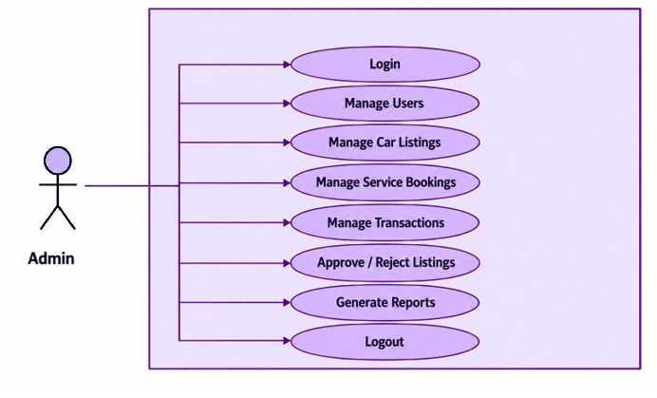

Seller Diagram
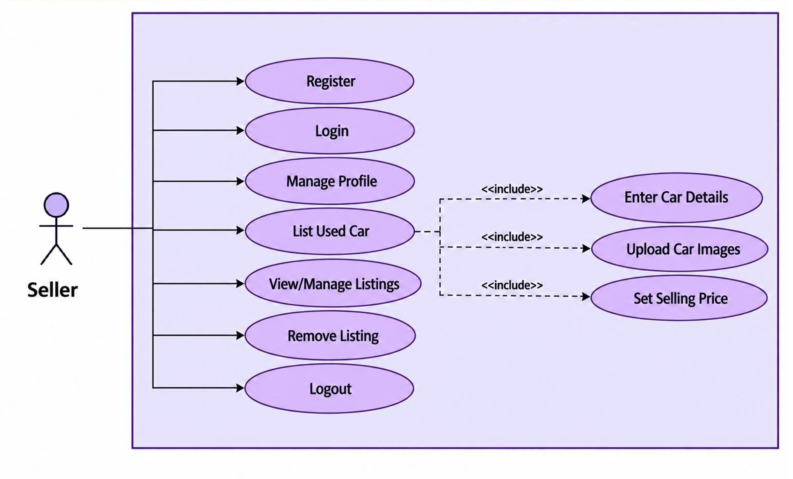
Customer (User) Diagram
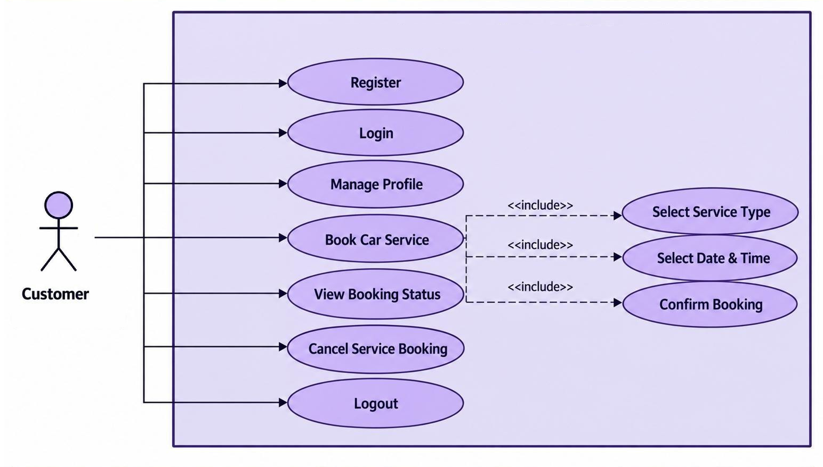

3.2 Data Dictionary
The Data Dictionary describes the database structure of CarZen. It lists each database table, its fields, data types, key information, nullability, default values and the purpose of each field. The dictionary is prepared directly from the project's SQL database schema (carzen_db_v6.sql). The car_price_predict table, which stores the price-prediction history, is created by the application from its model definition, and the alembic_version table used for database migrations is not listed.

users
Field Name | Data Type | Nullable | Default | Key | Description
id | bigint | No | — | Primary Key | Unique identifier.
first_name | varchar(100) | No | — | — | First name of the user.
last_name | varchar(100) | Yes | — | — | Last name of the user.
username | varchar(100) | No | — | Unique | Unique username of the user.
email | varchar(255) | No | — | Unique | Unique email address (used to log in).
password | varchar(255) | No | — | — | Password stored as a bcrypt hash (never as plain text).
phone_number | varchar(20) | Yes | — | Unique | Unique contact phone number of the user.
role | ENUM | No | — | — | Role of the account: USER or ADMIN. Values: USER, ADMIN.
status | ENUM | No | — | — | Account status: ACTIVE, INACTIVE or BLOCKED. Values: ACTIVE, INACTIVE, BLOCKED.
profile_image_url | varchar(500) | Yes | — | — | URL of the profile image.
created_at | datetime | Yes | — | — | Date and time when the record was created.
updated_at | datetime | Yes | — | — | Date and time when the record was last updated.
deleted_at | datetime | Yes | — | — | Date and time of soft deletion (empty while the record is active).

addresses
Field Name | Data Type | Nullable | Default | Key | Description
id | bigint | No | — | Primary Key | Unique identifier.
user_id | bigint | No | — | Foreign Key | Identifier of the related user.
address_line_1 | varchar(255) | No | — | — | Primary address line.
address_line_2 | varchar(255) | Yes | — | — | Additional address line.
landmark | varchar(255) | Yes | — | — | Nearby landmark.
city | varchar(100) | No | — | — | City.
state | varchar(100) | No | — | — | State or region.
country | varchar(100) | No | — | — | Country.
postal_code | varchar(10) | No | — | — | Postal / PIN code.
latitude | decimal(10,7) | Yes | — | — | Geographical latitude.
longitude | decimal(10,7) | Yes | — | — | Geographical longitude.
is_default | boolean | Yes | — | — | Indicates whether this is the user's default address.
created_at | datetime | Yes | — | — | Date and time when the record was created.
updated_at | datetime | Yes | — | — | Date and time when the record was last updated.
deleted_at | datetime | Yes | — | — | Date and time of soft deletion (empty while the record is active).

contacts
Field Name | Data Type | Nullable | Default | Key | Description
id | bigint | No | — | Primary Key | Unique identifier.
user_id | bigint | No | — | Foreign Key | Identifier of the related user.
address_id | bigint | No | — | Foreign Key | Identifier of the related address.
whatsapp_number | varchar(20) | Yes | — | — | WhatsApp number of the user.
preferred_contact_method | ENUM | No | — | — | Preferred way to be contacted: PHONE, EMAIL or WHATSAPP. Values: PHONE, EMAIL, WHATSAPP.
contact_visibility | ENUM | No | — | — | Who can see the contact details: PUBLIC, BUYERS_ONLY or PRIVATE. Values: PUBLIC, BUYERS_ONLY, PRIVATE.
is_visible | boolean | No | — | — | Indicates whether the contact details are visible.
created_at | datetime | Yes | — | — | Date and time when the record was created.
updated_at | datetime | Yes | — | — | Date and time when the record was last updated.
deleted_at | datetime | Yes | — | — | Date and time of soft deletion (empty while the record is active).

car_brands
Field Name | Data Type | Nullable | Default | Key | Description
id | bigint | No | — | Primary Key | Unique identifier.
name | varchar(100) | No | — | Unique | Unique name of the car brand.
slug | varchar(120) | No | — | Unique | Unique URL-friendly identifier.
country | varchar(100) | Yes | — | — | Country of the brand.
logo_url | varchar(500) | Yes | — | — | URL of the brand logo.
description | text | Yes | — | — | Description or additional details.
is_active | boolean | Yes | — | — | Indicates whether the brand is active in the catalogue.
created_at | datetime | Yes | — | — | Date and time when the record was created.
updated_at | datetime | Yes | — | — | Date and time when the record was last updated.
deleted_at | datetime | Yes | — | — | Date and time of soft deletion (empty while the record is active).

car_models
Field Name | Data Type | Nullable | Default | Key | Description
id | bigint | No | — | Primary Key | Unique identifier.
brand_id | bigint | No | — | Foreign Key | Identifier of the related car brand.
name | varchar(100) | No | — | — | Name of the car model.
slug | varchar(120) | No | — | Unique | Unique URL-friendly identifier.
body_type | ENUM | Yes | — | — | Body type of the car model. Values: HATCHBACK, SEDAN, SUV, MUV, MPV, COUPE, CONVERTIBLE, PICKUP, MINIVAN, OTHER.
seating_capacity | integer | Yes | — | — | Number of seats.
description | text | Yes | — | — | Description or additional details.
is_active | boolean | Yes | — | — | Indicates whether the model is active in the catalogue.
created_at | datetime | Yes | — | — | Date and time when the record was created.
updated_at | datetime | Yes | — | — | Date and time when the record was last updated.
deleted_at | datetime | Yes | — | — | Date and time of soft deletion (empty while the record is active).

car_variants
Field Name | Data Type | Nullable | Default | Key | Description
id | bigint | No | — | Primary Key | Unique identifier.
model_id | bigint | No | — | Foreign Key | Identifier of the related car model.
variant_name | varchar(150) | No | — | — | Name of the car variant.
fuel_type | ENUM | No | — | — | Fuel type of the vehicle. Values: PETROL, DIESEL, CNG, ELECTRIC, HYBRID.
transmission | ENUM | No | — | — | Transmission type of the vehicle. Values: MANUAL, AUTOMATIC, AMT, CVT, DCT.
engine_cc | decimal(8,2) | Yes | — | — | Engine capacity in cubic centimetres.
horsepower | decimal(8,2) | Yes | — | — | Engine power in horsepower.
seating_capacity | integer | Yes | — | — | Number of seats.
ex_showroom_price | decimal(15,2) | Yes | — | — | Ex-showroom price of the variant.
created_at | datetime | Yes | — | — | Date and time when the record was created.
updated_at | datetime | Yes | — | — | Date and time when the record was last updated.
deleted_at | datetime | Yes | — | — | Date and time of soft deletion (empty while the record is active).

cars
Field Name | Data Type | Nullable | Default | Key | Description
id | bigint | No | — | Primary Key | Unique identifier.
variant_id | bigint | No | — | Foreign Key | Identifier of the related car variant.
owner_id | bigint | No | — | Foreign Key | Identifier of the user who owns the car.
registration_number | varchar(30) | Yes | — | Unique | Unique vehicle registration number.
vin_number | varchar(100) | Yes | — | Unique | Unique vehicle identification number (VIN).
manufacturing_year | integer | No | — | — | Year in which the vehicle was manufactured.
registration_year | integer | Yes | — | — | Year in which the vehicle was registered.
fuel_type | ENUM | No | — | — | Fuel type of the vehicle. Values: PETROL, DIESEL, CNG, ELECTRIC, HYBRID.
transmission | ENUM | No | — | — | Transmission type of the vehicle. Values: MANUAL, AUTOMATIC, AMT, CVT, DCT.
engine_cc | decimal(8,2) | Yes | — | — | Engine capacity in cubic centimetres.
horsepower | decimal(8,2) | Yes | — | — | Engine power in horsepower.
mileage_km | decimal(12,2) | No | — | — | Distance travelled by the vehicle in kilometres.
color | varchar(50) | Yes | — | — | Vehicle colour.
seating_capacity | integer | Yes | — | — | Number of seats.
owner_count | integer | Yes | — | — | Number of owners the vehicle has had.
ownership_type | ENUM | Yes | — | — | Ownership sequence of the vehicle. Values: FIRST_OWNER, SECOND_OWNER, THIRD_OWNER, FOURTH_OR_MORE.
condition | ENUM | Yes | — | — | Current condition of the vehicle. Values: EXCELLENT, GOOD, FAIR, POOR, NEW, OLD.
insurance_company | varchar(150) | Yes | — | — | Name of the insurance company.
insurance_type | varchar(100) | Yes | — | — | Type of insurance.
insurance_expiry | date | Yes | — | — | Insurance expiry date.
rc_status | varchar(50) | Yes | — | — | Registration Certificate (RC) status.
city | varchar(100) | No | — | — | City.
state | varchar(100) | No | — | — | State or region.
country | varchar(100) | No | — | — | Country.
postal_code | varchar(10) | Yes | — | — | Postal / PIN code.
description | text | Yes | — | — | Seller's description of the car.
expected_market_price | decimal(15,2) | Yes | — | — | Expected market price of the car.
is_verified | boolean | Yes | — | — | Indicates whether the car is verified by the administrator.
approval_status | ENUM | No | — | — | Approval / lifecycle status of the car. Values: draft, pending_approval, approved, rejected, published, sold, inactive.
rejection_reason | text | Yes | — | — | Reason given by the administrator when a car is rejected.
verified_at | datetime | Yes | — | — | Date and time of admin verification.
verified_by_id | bigint | Yes | — | Foreign Key | Identifier of the administrator who verified or rejected the car.
created_at | datetime | Yes | — | — | Date and time when the record was created.
updated_at | datetime | Yes | — | — | Date and time when the record was last updated.
deleted_at | datetime | Yes | — | — | Date and time of soft deletion (empty while the record is active).

car_features
Field Name | Data Type | Nullable | Default | Key | Description
id | bigint | No | — | Primary Key | Unique identifier.
car_id | bigint | No | — | Foreign Key | Identifier of the related car.
feature_name | varchar(150) | No | — | — | Name of the feature (e.g. Sunroof).
feature_value | varchar(255) | Yes | — | — | Value or detail of the feature.
created_at | datetime | Yes | — | — | Date and time when the record was created.

car_media
Field Name | Data Type | Nullable | Default | Key | Description
id | bigint | No | — | Primary Key | Unique identifier.
car_id | bigint | No | — | Foreign Key | Identifier of the related car.
media_type | ENUM | No | — | — | Type of media: IMAGE or VIDEO. Values: IMAGE, VIDEO.
media_url | varchar(500) | No | — | — | URL of the media file.
thumbnail_url | varchar(500) | Yes | — | — | URL of the media thumbnail.
file_name | varchar(255) | Yes | — | — | Name of the uploaded file.
file_size | bigint | Yes | — | — | Size of the uploaded file.
sort_order | integer | Yes | — | — | Display order of the media item.
is_primary | boolean | Yes | — | — | Indicates whether this is the primary (cover) image.
created_at | datetime | Yes | — | — | Date and time when the record was created.
deleted_at | datetime | Yes | — | — | Date and time of soft deletion (empty while the record is active).

listings
Field Name | Data Type | Nullable | Default | Key | Description
id | bigint | No | — | Primary Key | Unique identifier.
car_id | bigint | No | — | Foreign Key | Identifier of the related car.
seller_id | bigint | No | — | Foreign Key | Identifier of the seller.
listing_type | ENUM | No | — | — | Type of listing: SALE or RESALE. Values: SALE, RESALE.
title | varchar(255) | No | — | — | Title of the listing.
description | text | Yes | — | — | Description of the listing.
asking_price | decimal(15,2) | No | — | — | Price requested by the seller.
negotiable | boolean | Yes | — | — | Indicates whether the asking price is negotiable.
listing_status | ENUM | Yes | — | — | Current status of the listing. Values: DRAFT, PENDING_REVIEW, APPROVED, REJECTED, ACTIVE, RESERVED, SOLD, EXPIRED, CANCELLED, REMOVED, SUSPENDED.
listed_at | datetime | Yes | — | — | Date and time when the listing was published.
expiry_date | datetime | Yes | — | — | Date and time when the listing expires.
views_count | integer | Yes | — | — | Number of times the listing was viewed.
created_at | datetime | Yes | — | — | Date and time when the record was created.
updated_at | datetime | Yes | — | — | Date and time when the record was last updated.
deleted_at | datetime | Yes | — | — | Date and time of soft deletion (empty while the record is active).

listing_views
Field Name | Data Type | Nullable | Default | Key | Description
id | bigint | No | — | Primary Key | Unique identifier.
listing_id | bigint | No | — | Foreign Key | Identifier of the related listing.
buyer_id | bigint | No | — | Foreign Key | Identifier of the buyer.
viewed_at | datetime | No | — | — | Date and time when the buyer viewed the listing.

favorites
Field Name | Data Type | Nullable | Default | Key | Description
id | bigint | No | — | Primary Key | Unique identifier.
user_id | bigint | No | — | Foreign Key | Identifier of the related user.
car_id | bigint | No | — | Foreign Key | Identifier of the related car.
created_at | datetime | Yes | — | — | Date and time when the record was created.

inquiries
Field Name | Data Type | Nullable | Default | Key | Description
id | bigint | No | — | Primary Key | Unique identifier.
listing_id | bigint | No | — | Foreign Key | Identifier of the related listing.
buyer_id | bigint | No | — | Foreign Key | Identifier of the buyer.
seller_id | bigint | No | — | Foreign Key | Identifier of the seller.
subject | varchar(255) | Yes | — | — | Subject of the inquiry.
message | text | No | — | — | Message sent with the inquiry.
status | ENUM | Yes | — | — | Current status of the inquiry. Values: OPEN, CONTACTED, CLOSED.
created_at | datetime | Yes | — | — | Date and time when the record was created.
updated_at | datetime | Yes | — | — | Date and time when the record was last updated.

inquiry_messages
Field Name | Data Type | Nullable | Default | Key | Description
id | bigint | No | — | Primary Key | Unique identifier.
inquiry_id | bigint | No | — | Foreign Key | Identifier of the related inquiry.
sender_id | bigint | No | — | Foreign Key | Identifier of the user who sent the message.
message | text | No | — | — | Text of the message in the inquiry thread.
created_at | datetime | No | — | — | Date and time when the record was created.

orders
Field Name | Data Type | Nullable | Default | Key | Description
id | bigint | No | — | Primary Key | Unique identifier.
listing_id | bigint | No | — | Foreign Key | Identifier of the related listing.
car_id | bigint | No | — | Foreign Key | Identifier of the related car.
buyer_id | bigint | No | — | Foreign Key | Identifier of the buyer.
seller_id | bigint | No | — | Foreign Key | Identifier of the seller.
amount | decimal(15,2) | No | — | — | Order amount (asking price of the listing).
status | ENUM | No | — | — | Current status of the order. Values: PENDING, CONFIRMED, PROCESSING, COMPLETED, CANCELLED, REJECTED.
payment_status | ENUM | No | — | — | Current payment status of the order. Values: PENDING, PARTIAL, PAID, FAILED, REFUNDED, UNPAID.
notes | text | Yes | — | — | Notes added by the buyer.
created_at | datetime | No | — | — | Date and time when the record was created.
updated_at | datetime | No | — | — | Date and time when the record was last updated.
completed_at | datetime | Yes | — | — | Date and time when the order was completed.

transactions
Field Name | Data Type | Nullable | Default | Key | Description
id | bigint | No | — | Primary Key | Unique identifier.
listing_id | bigint | No | — | Foreign Key | Identifier of the related listing.
order_id | bigint | No | — | Foreign Key, Unique | Identifier of the related order.
car_id | bigint | No | — | Foreign Key | Identifier of the related car.
buyer_id | bigint | No | — | Foreign Key | Identifier of the buyer.
seller_id | bigint | No | — | Foreign Key | Identifier of the seller.
final_price | decimal(15,2) | No | — | — | Final transaction price.
transaction_date | datetime | Yes | — | — | Date and time of the transaction.
payment_method | ENUM | Yes | — | — | Method used for payment. Values: CASH, UPI, CARD, BANK_TRANSFER, FINANCE, OTHER.
payment_status | ENUM | Yes | — | — | Current payment status. Values: PENDING, PARTIAL, PAID, FAILED, REFUNDED, UNPAID.
transaction_status | ENUM | Yes | — | — | Current transaction status. Values: INITIATED, COMPLETED, CANCELLED, FAILED.
notes | text | Yes | — | — | Additional transaction notes.
created_at | datetime | Yes | — | — | Date and time when the record was created.
updated_at | datetime | Yes | — | — | Date and time when the record was last updated.

payments
Field Name | Data Type | Nullable | Default | Key | Description
id | bigint | No | — | Primary Key | Unique identifier.
transaction_id | bigint | Yes | — | Foreign Key | Identifier of the related transaction (if any).
order_id | bigint | Yes | — | Foreign Key | Identifier of the related order (car payment).
user_id | bigint | Yes | — | Foreign Key | Identifier of the user who made the payment.
service_request_id | bigint | Yes | — | Foreign Key | Identifier of the related service request (service payment).
amount | decimal(15,2) | No | — | — | Payment amount.
currency | varchar(10) | Yes | — | — | Currency used for the payment (e.g. INR).
payment_method | ENUM | Yes | — | — | Method used for payment. Values: CASH, UPI, CARD, BANK_TRANSFER, FINANCE, OTHER.
provider | varchar(100) | Yes | — | — | Payment provider (e.g. Razorpay or cash).
provider_transaction_id | varchar(255) | Yes | — | — | Transaction identifier supplied by the payment provider.
status | ENUM | No | — | — | Current payment status. Values: pending, processing, success, failed, cancelled, refunded.
razorpay_order_id | varchar(255) | Yes | — | Unique | Unique Razorpay order identifier.
razorpay_payment_id | varchar(255) | Yes | — | Unique | Unique Razorpay payment identifier.
razorpay_signature | varchar(512) | Yes | — | — | Razorpay signature used to verify the payment.
payment_date | datetime | Yes | — | — | Date and time of payment.
metadata | json | Yes | — | — | Additional payment details in JSON format.
created_at | datetime | Yes | — | — | Date and time when the record was created.
updated_at | datetime | Yes | — | — | Date and time when the record was last updated.

reviews
Field Name | Data Type | Nullable | Default | Key | Description
id | bigint | No | — | Primary Key | Unique identifier.
user_id | bigint | No | — | Foreign Key | Identifier of the related user.
car_id | bigint | Yes | — | Foreign Key | Identifier of the related car.
listing_id | bigint | Yes | — | Foreign Key | Identifier of the related listing.
transaction_id | bigint | Yes | — | Foreign Key | Identifier of the related transaction.
rating | integer | No | — | — | Rating given by the user (1 to 5).
title | varchar(255) | Yes | — | — | Title of the review.
review_text | text | Yes | — | — | Review content.
is_visible | boolean | Yes | — | — | Indicates whether the review is visible to the public.
created_at | datetime | Yes | — | — | Date and time when the record was created.
updated_at | datetime | Yes | — | — | Date and time when the record was last updated.
deleted_at | datetime | Yes | — | — | Date and time of soft deletion (empty while the record is active).

reports
Field Name | Data Type | Nullable | Default | Key | Description
id | bigint | No | — | Primary Key | Unique identifier.
reporter_id | bigint | No | — | Foreign Key | Identifier of the user who submitted the report.
listing_id | bigint | Yes | — | Foreign Key | Identifier of the related listing.
car_id | bigint | Yes | — | Foreign Key | Identifier of the related car.
reason | ENUM | No | — | — | Reason for submitting the report. Values: fake_listing, wrong_information, fraud, duplicate_listing, suspicious_seller, inappropriate_content, other.
description | text | Yes | — | — | Details provided by the reporter.
status | ENUM | No | — | — | Current status of the report. Values: pending, under_review, resolved, rejected.
created_at | datetime | Yes | — | — | Date and time when the record was created.
resolved_at | datetime | Yes | — | — | Date and time when the report was resolved.
resolved_by_id | bigint | Yes | — | Foreign Key | Identifier of the administrator who handled the report.
admin_note | text | Yes | — | — | Note added by the administrator.

notifications
Field Name | Data Type | Nullable | Default | Key | Description
id | bigint | No | — | Primary Key | Unique identifier.
user_id | bigint | No | — | Foreign Key | Identifier of the related user.
title | varchar(255) | No | — | — | Title of the notification.
message | text | No | — | — | Notification message.
notification_type | varchar(100) | Yes | — | — | Type of notification (e.g. inquiry, order, payment).
reference_id | bigint | Yes | — | — | Identifier of the record referred to by the notification.
reference_type | varchar(100) | Yes | — | — | Type of record referred to by the notification.
is_read | boolean | Yes | — | — | Indicates whether the notification has been read.
created_at | datetime | Yes | — | — | Date and time when the record was created.

services
Field Name | Data Type | Nullable | Default | Key | Description
id | bigint | No | — | Primary Key | Unique identifier.
name | varchar(150) | No | — | — | Name of the service (e.g. Full Servicing).
description | text | Yes | — | — | What the service includes.
price | decimal(15,2) | No | — | — | Price of the service.
duration_minutes | integer | Yes | — | — | Estimated duration of the service in minutes.
image_url | varchar(500) | Yes | — | — | URL of the service image.
status | varchar(50) | No | — | — | Catalogue status of the service (active / inactive).
created_at | datetime | No | — | — | Date and time when the record was created.
updated_at | datetime | No | — | — | Date and time when the record was last updated.
deleted_at | datetime | Yes | — | — | Date and time of soft deletion (empty while the record is active).

service_requests
Field Name | Data Type | Nullable | Default | Key | Description
id | bigint | No | — | Primary Key | Unique identifier.
user_id | bigint | No | — | Foreign Key | Identifier of the user who requested the service.
car_id | bigint | No | — | Foreign Key | Identifier of the car to be serviced.
service_id | bigint | Yes | — | Foreign Key | Identifier of the first / main service requested.
address_id | bigint | Yes | — | Foreign Key | Identifier of the related address.
scheduled_date | date | No | — | — | Requested or confirmed service date.
scheduled_time | time | No | — | — | Requested or confirmed service time.
notes | text | Yes | — | — | Customer instructions or issues to inspect.
base_amount | decimal(15,2) | No | — | — | Total price of the selected services.
parts_cost | decimal(15,2) | No | — | — | Cost of parts added on completion.
labor_cost | decimal(15,2) | No | — | — | Labour cost added on completion.
total_amount | decimal(15,2) | No | — | — | Total bill amount (services + parts + labour).
amount | decimal(15,2) | No | — | — | Amount payable for the request.
payment_status | varchar(50) | No | — | — | Payment status of the request.
payment_method | varchar(50) | Yes | — | — | Method chosen for payment (online or cash).
status | ENUM | No | — | — | Current status of the service request. Values: requested, accepted, scheduled, in_progress, completed, cancelled, rejected.
admin_note | text | Yes | — | — | Note added by the administrator.
service_record_id | bigint | Yes | — | Foreign Key | Identifier of the service record created on completion.
invoice_pdf_path | varchar(500) | Yes | — | — | File path of the generated invoice PDF.
created_at | datetime | No | — | — | Date and time when the record was created.
updated_at | datetime | No | — | — | Date and time when the record was last updated.
deleted_at | datetime | Yes | — | — | Date and time of soft deletion (empty while the record is active).

service_request_items
Field Name | Data Type | Nullable | Default | Key | Description
id | bigint | No | — | Primary Key | Unique identifier.
service_request_id | bigint | No | — | Foreign Key | Identifier of the related service request.
service_id | bigint | Yes | — | Foreign Key | Identifier of the related service.
service_name | varchar(150) | No | — | — | Name of the service at the time of booking.
unit_price | decimal(15,2) | No | — | — | Price of the service at the time of booking.
duration_minutes | integer | Yes | — | — | Estimated duration of the service in minutes.
created_at | datetime | No | — | — | Date and time when the record was created.

service_records
Field Name | Data Type | Nullable | Default | Key | Description
id | bigint | No | — | Primary Key | Unique identifier.
car_id | bigint | No | — | Foreign Key | Identifier of the related car.
service_center_id | bigint | Yes | — | — | Reserved identifier of a service centre (not used; no service-centre table).
service_type | varchar(150) | No | — | — | Type of service performed.
service_date | date | No | — | — | Date of service.
odometer_reading | decimal(12,2) | Yes | — | — | Odometer reading at service time.
service_cost | decimal(15,2) | Yes | — | — | Total service cost.
parts_cost | decimal(15,2) | Yes | — | — | Cost of parts.
labor_cost | decimal(15,2) | Yes | — | — | Labour cost.
description | text | Yes | — | — | Description of the work done.
next_service_date | date | Yes | — | — | Recommended next service date.
next_service_mileage | decimal(12,2) | Yes | — | — | Recommended next service mileage.
status | ENUM | Yes | — | — | Current status of the service record. Values: scheduled, completed, cancelled.
created_at | datetime | Yes | — | — | Date and time when the record was created.
updated_at | datetime | Yes | — | — | Date and time when the record was last updated.

service_items
Field Name | Data Type | Nullable | Default | Key | Description
id | bigint | No | — | Primary Key | Unique identifier.
service_record_id | bigint | No | — | Foreign Key | Identifier of the related service record.
item_name | varchar(150) | No | — | — | Name of the service item.
quantity | integer | Yes | — | — | Quantity of the service item.
unit_cost | decimal(15,2) | Yes | — | — | Cost per unit.
total_cost | decimal(15,2) | Yes | — | — | Total cost for the service item.
created_at | datetime | Yes | — | — | Date and time when the record was created.

price_predictions
Field Name | Data Type | Nullable | Default | Key | Description
id | bigint | No | — | Primary Key | Unique identifier.
car_id | bigint | Yes | — | Foreign Key | Identifier of the related car.
user_id | bigint | No | — | Foreign Key | Identifier of the related user.
prediction_status | ENUM | Yes | — | — | Status of the prediction: REQUESTED, COMPLETED or FAILED. Values: REQUESTED, COMPLETED, FAILED.
predicted_price | decimal(15,2) | Yes | — | — | Predicted price.
minimum_price | decimal(15,2) | Yes | — | — | Minimum of the predicted price range.
maximum_price | decimal(15,2) | Yes | — | — | Maximum of the predicted price range.
confidence_score | decimal(5,2) | Yes | — | — | Confidence of the prediction.
model_name | varchar(150) | Yes | — | — | Name of the prediction model.
model_version | varchar(100) | Yes | — | — | Version of the prediction model.
prediction_input | json | Yes | — | — | Input values of the prediction in JSON format.
prediction_date | datetime | Yes | — | — | Date and time of the prediction.
created_at | datetime | Yes | — | — | Date and time when the record was created.

3.3 User Interface Design
Home Page:
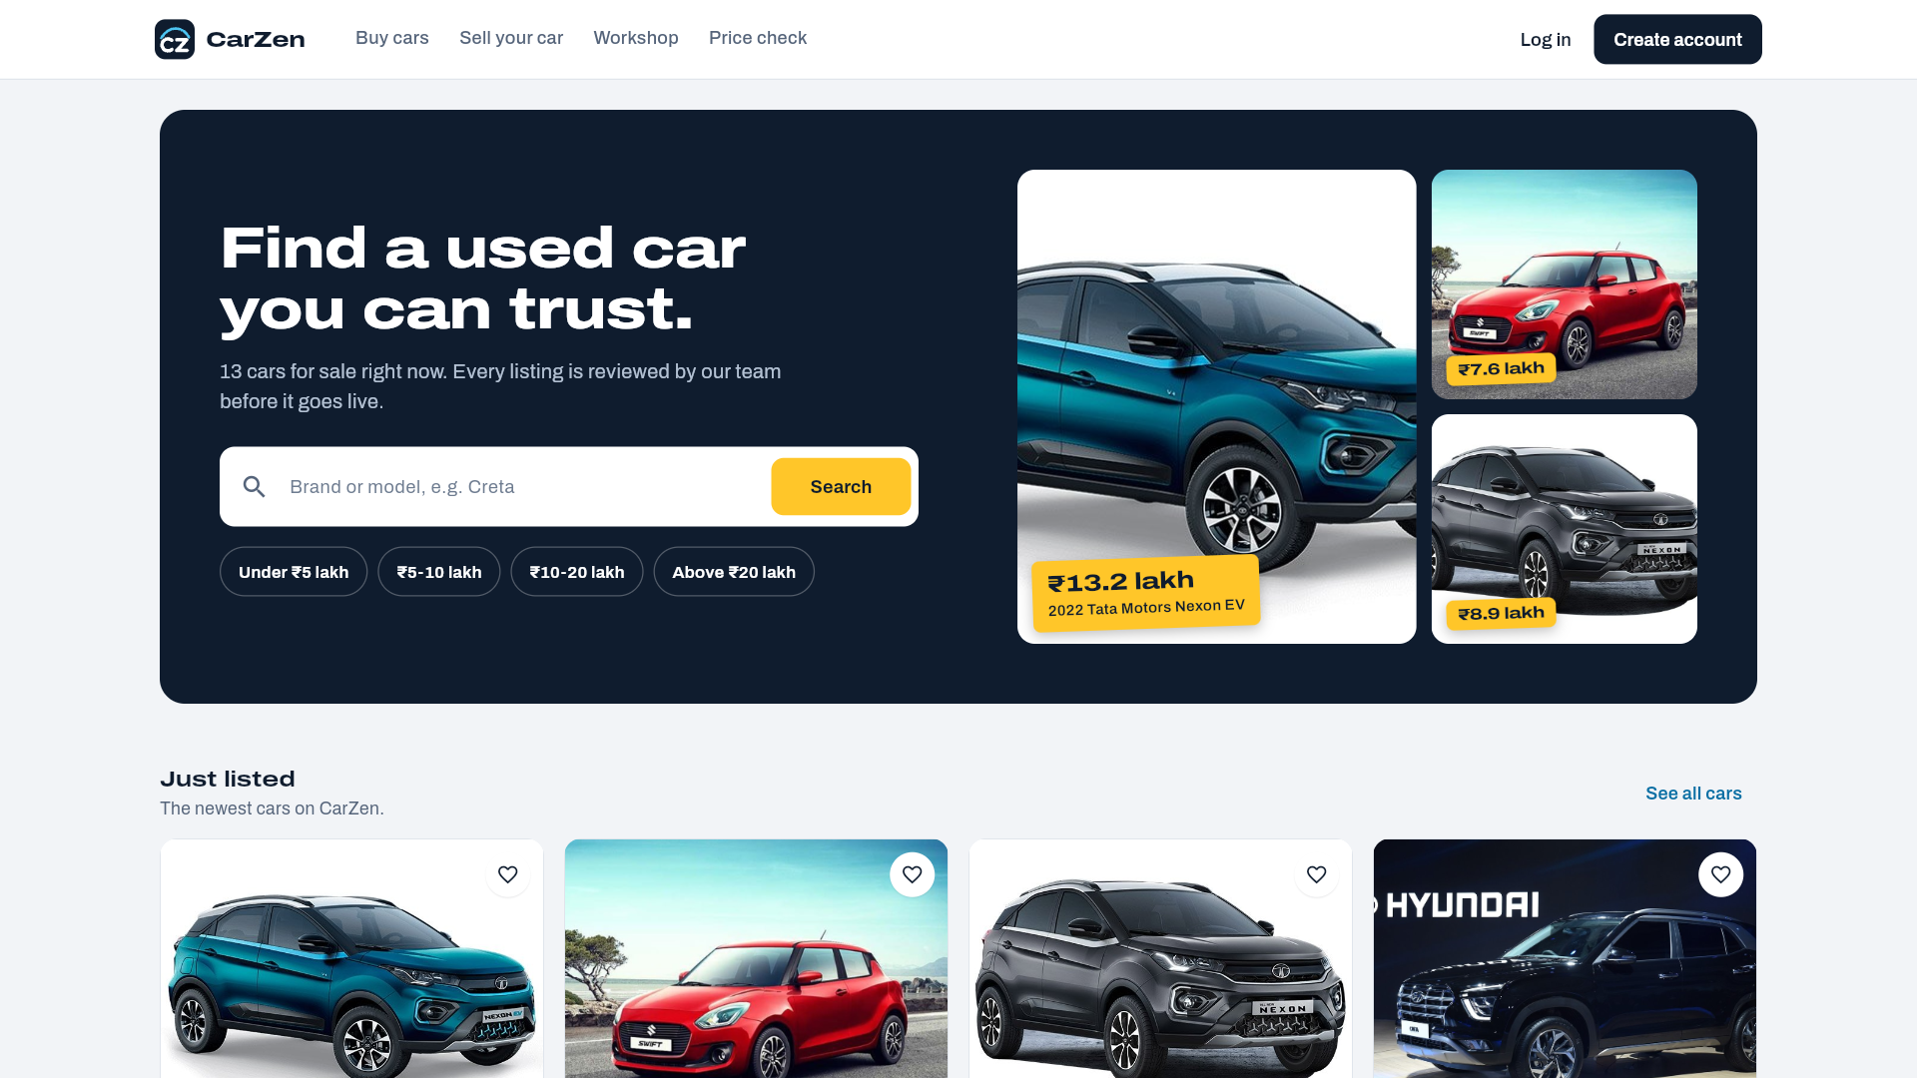
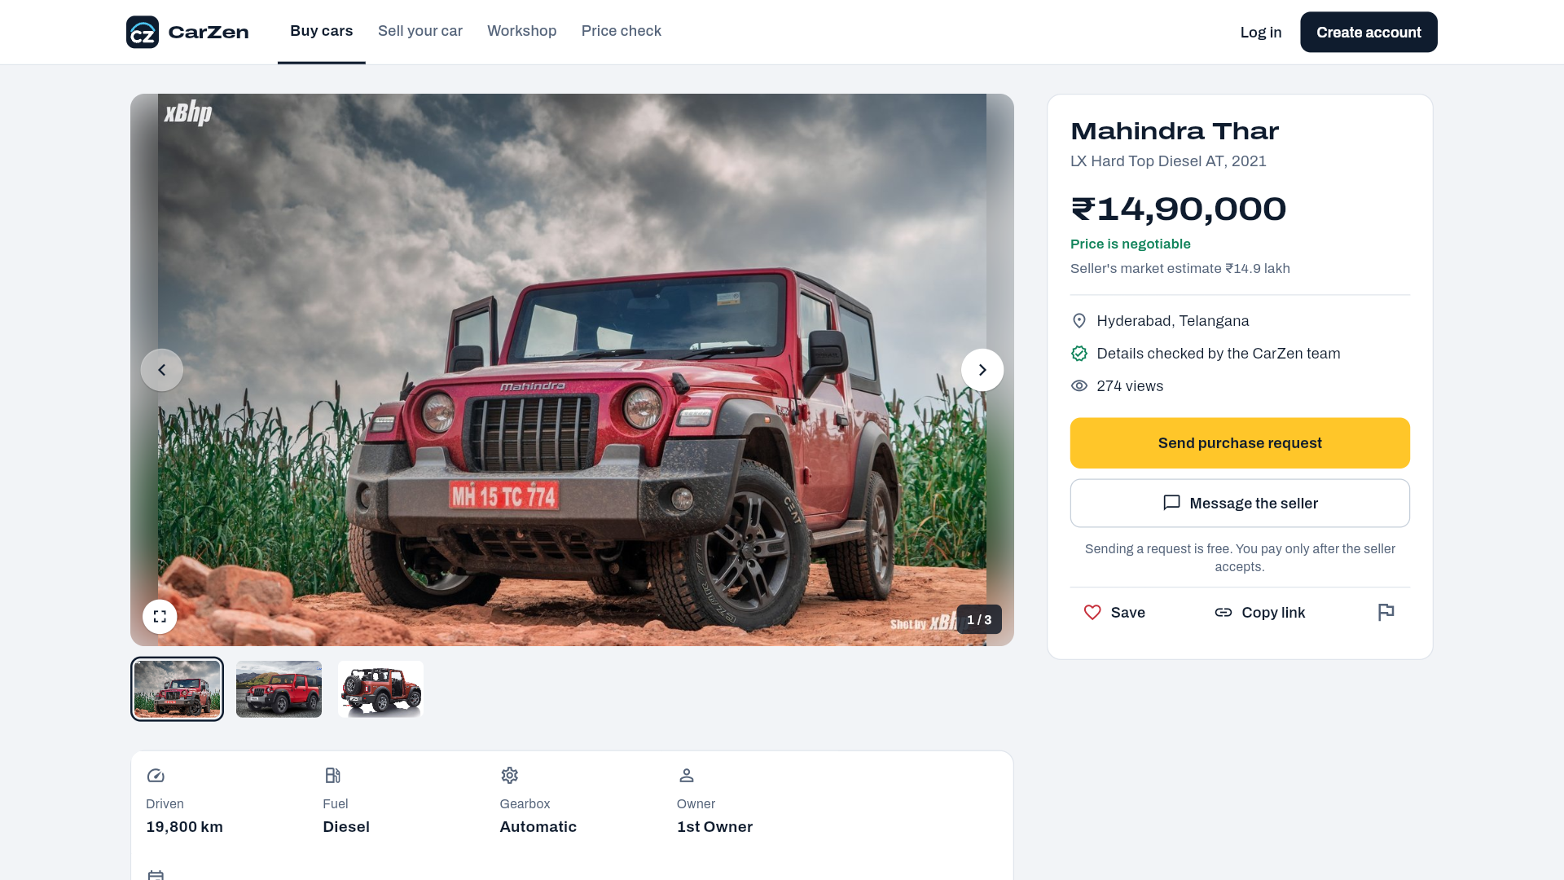
Login Page:
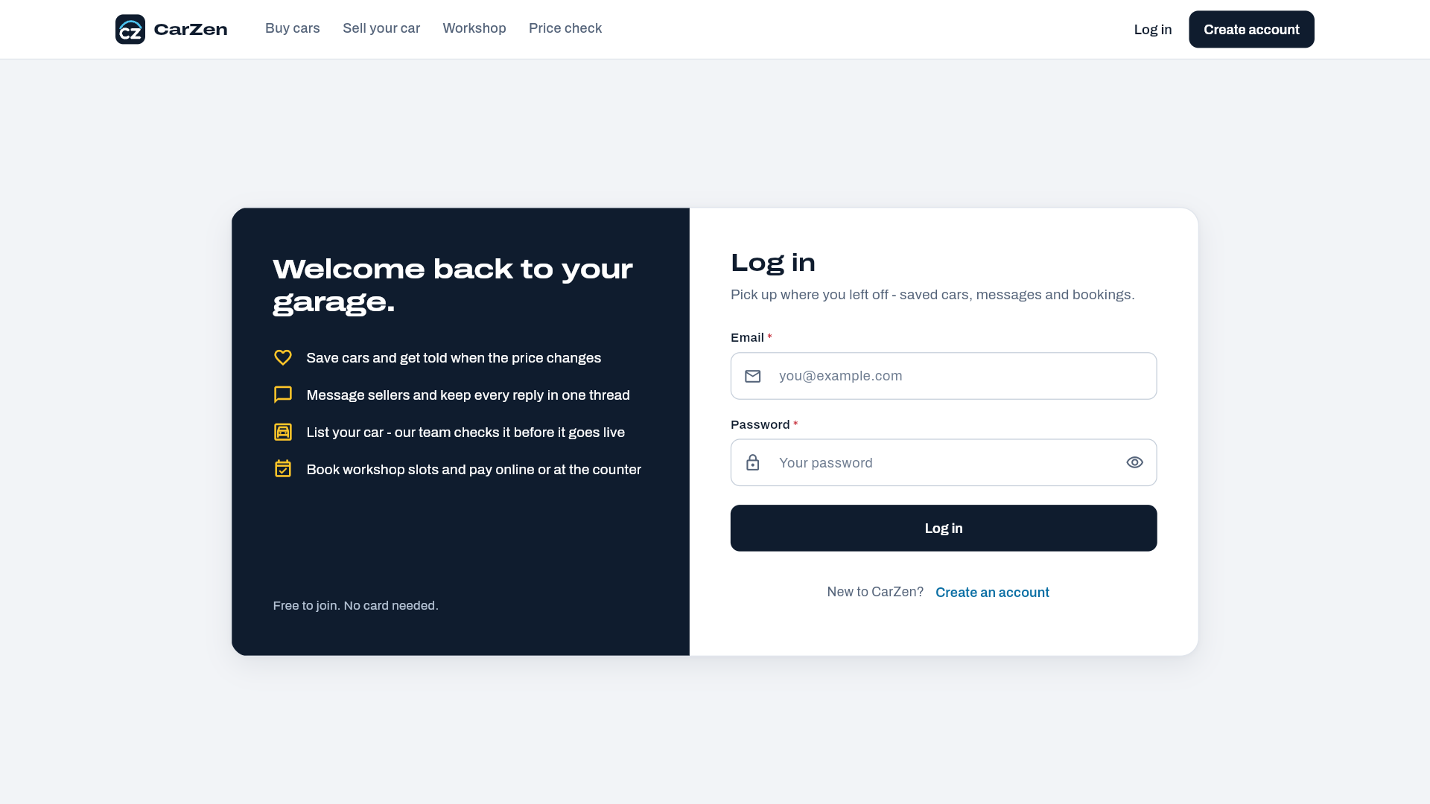
Register Page:
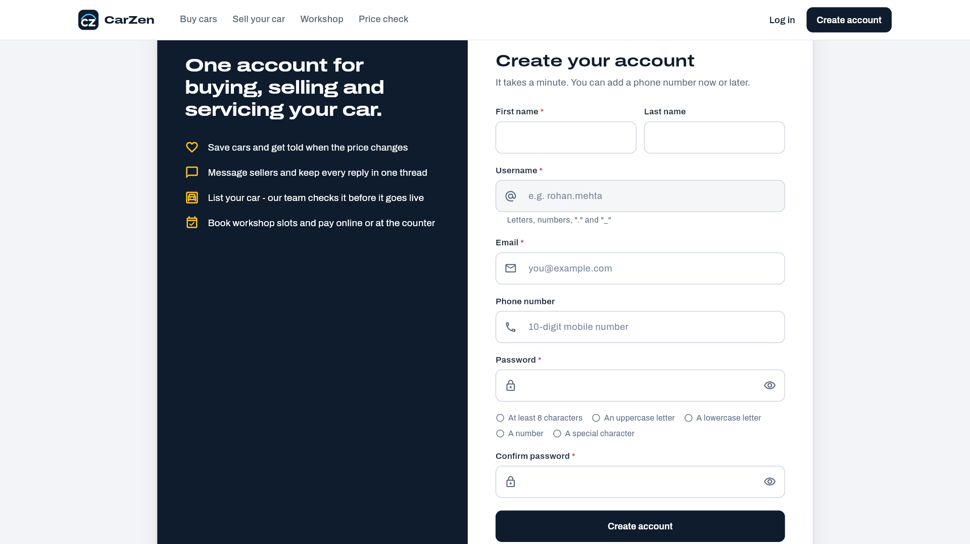
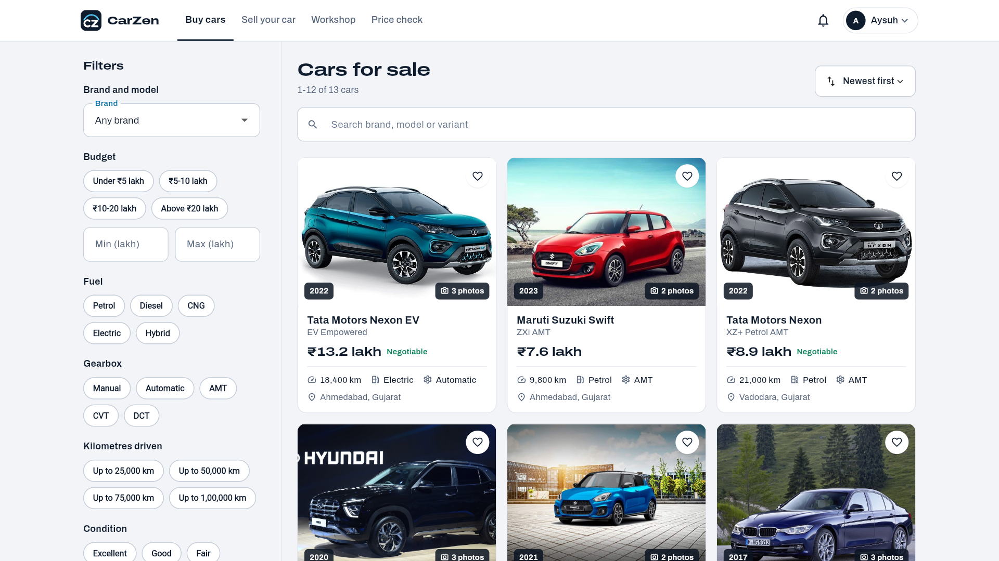
Price Prediction Page:
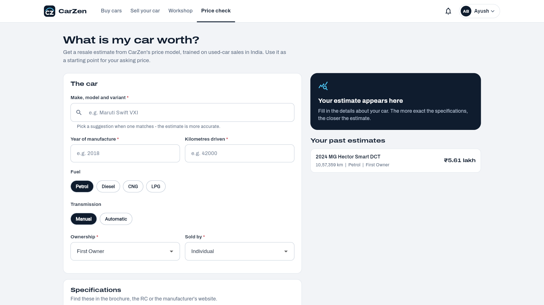

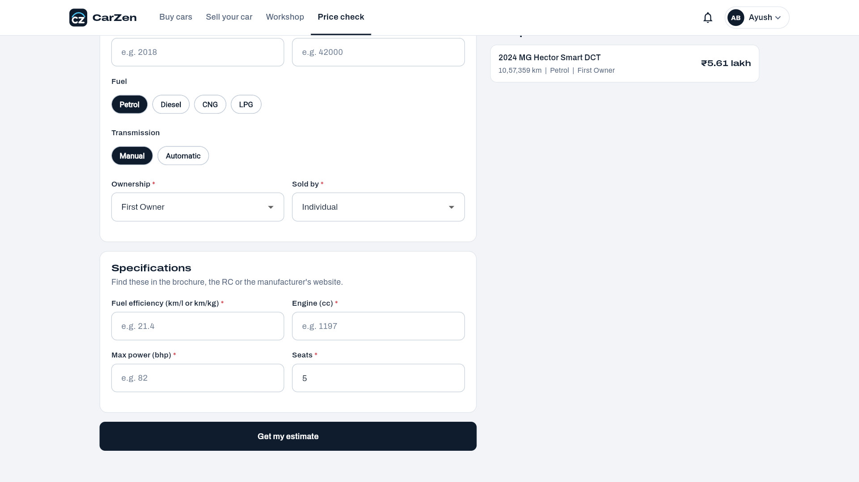
Admin:
Dashboard:
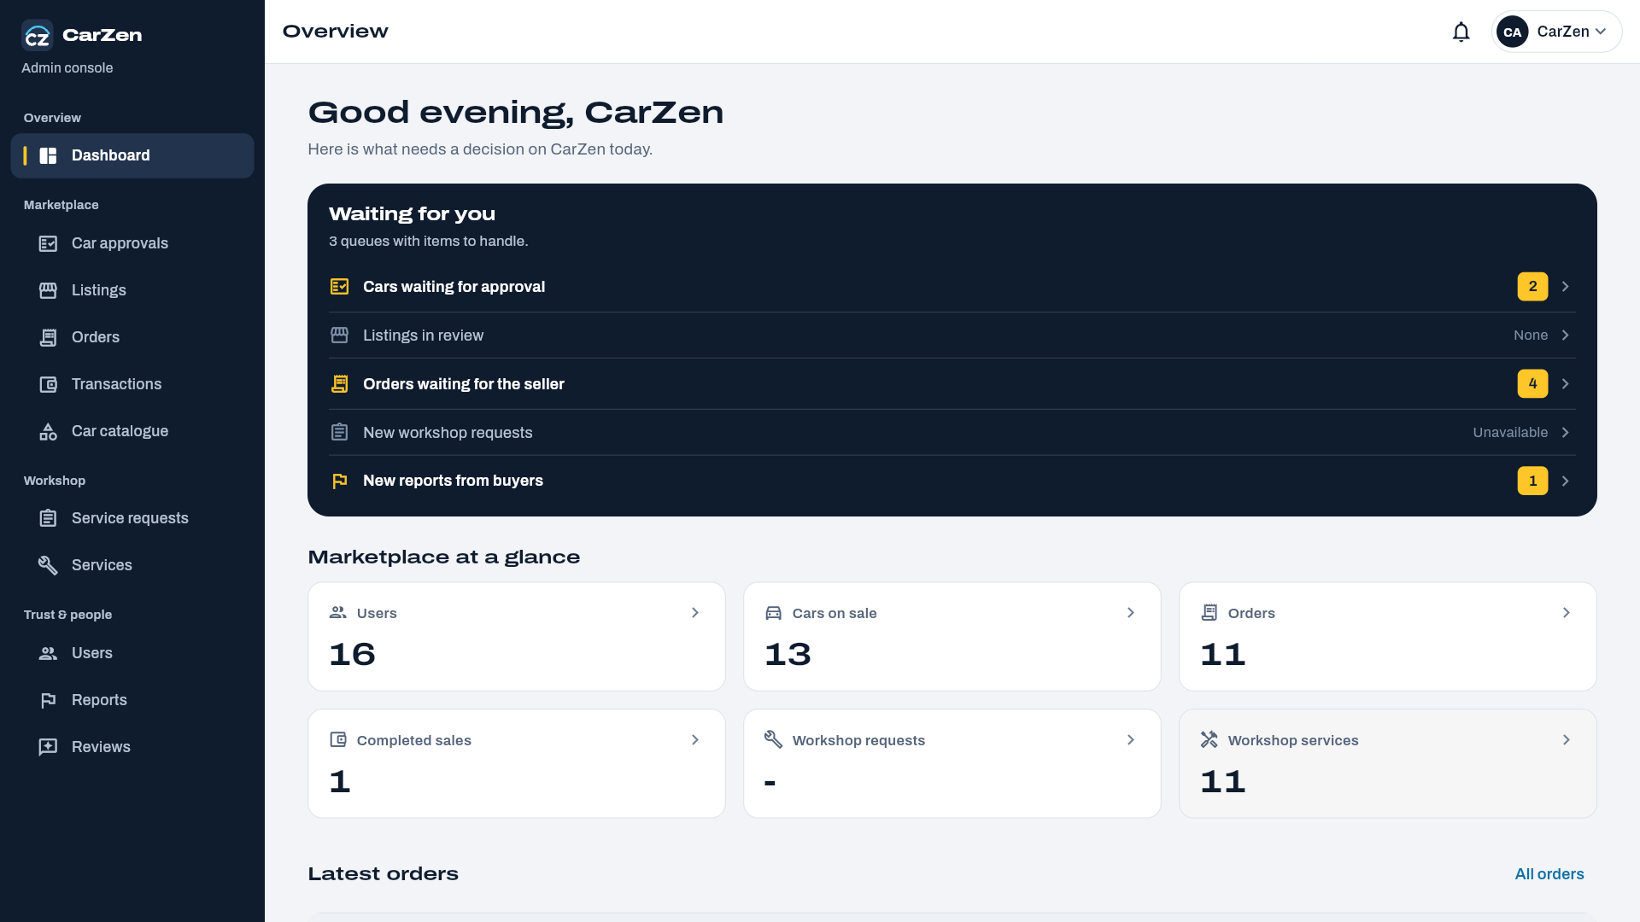

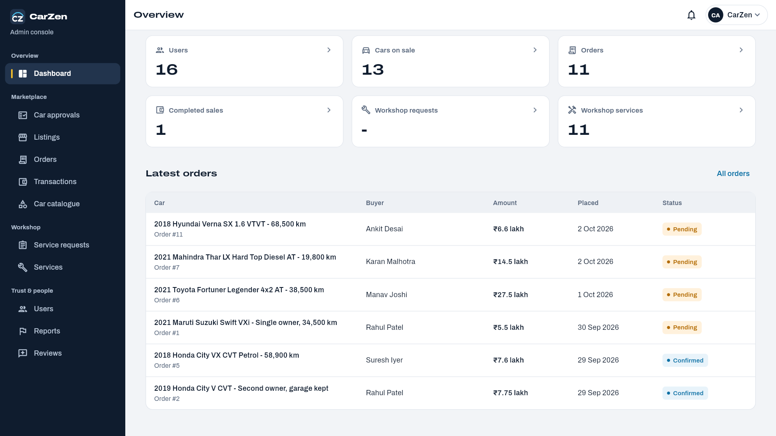

Car Approval page:
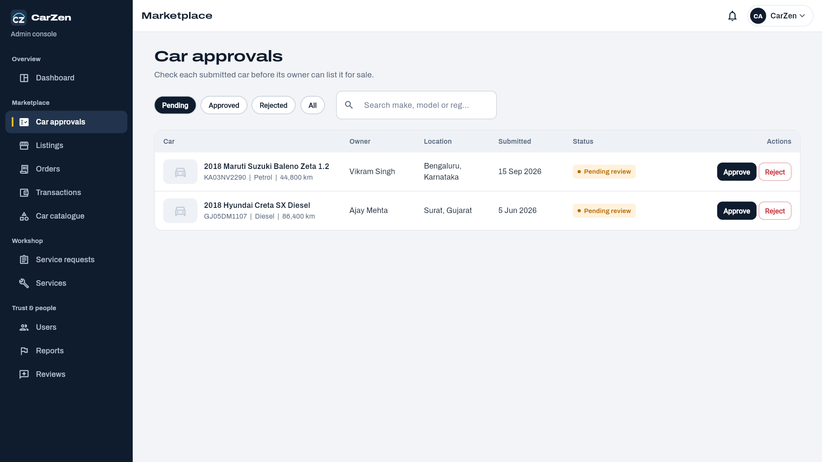
Car Listings page:
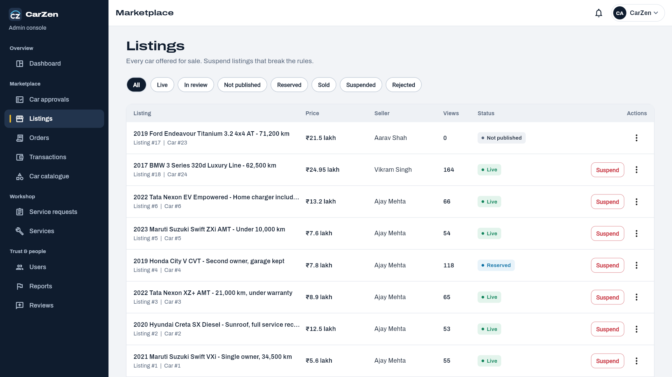
Order Page:
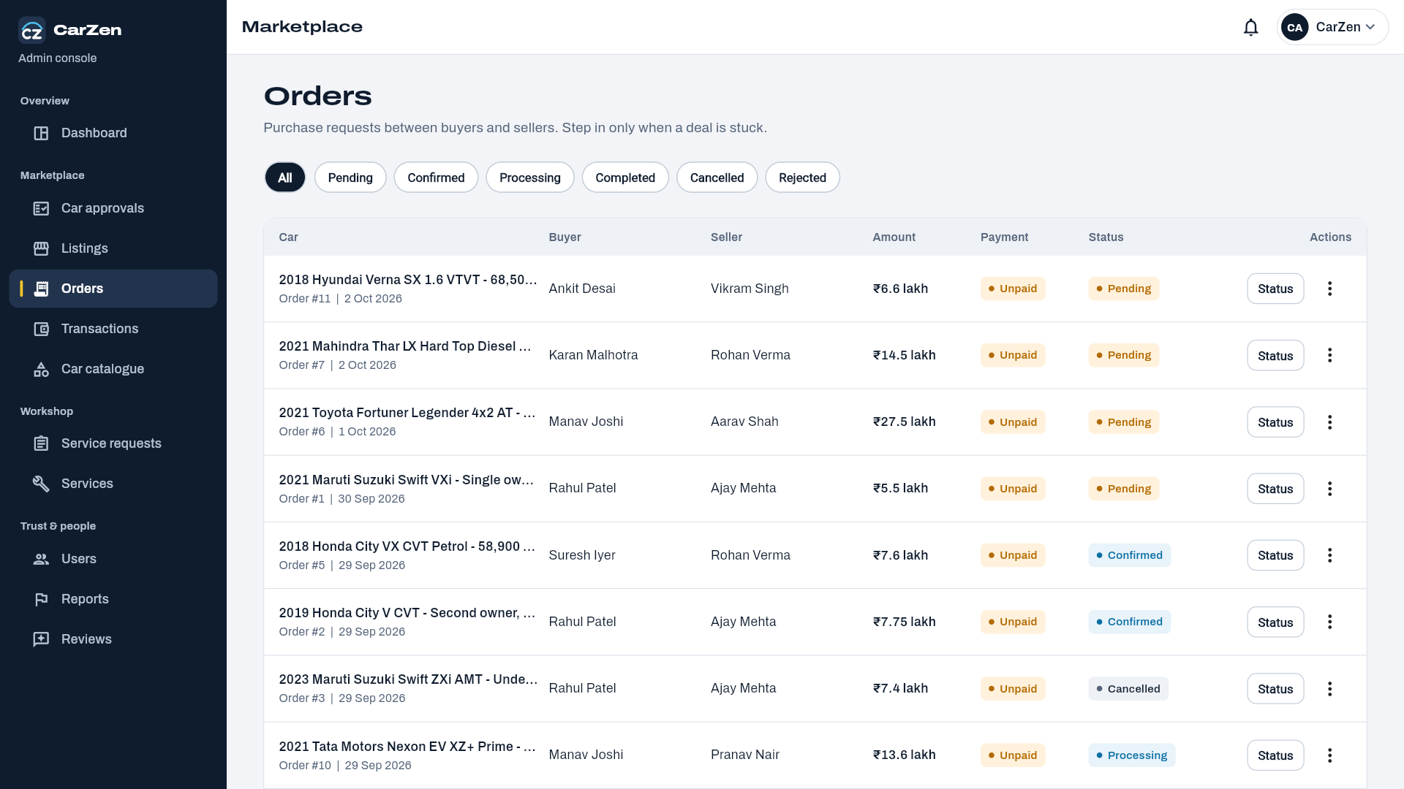
Transaction Page:
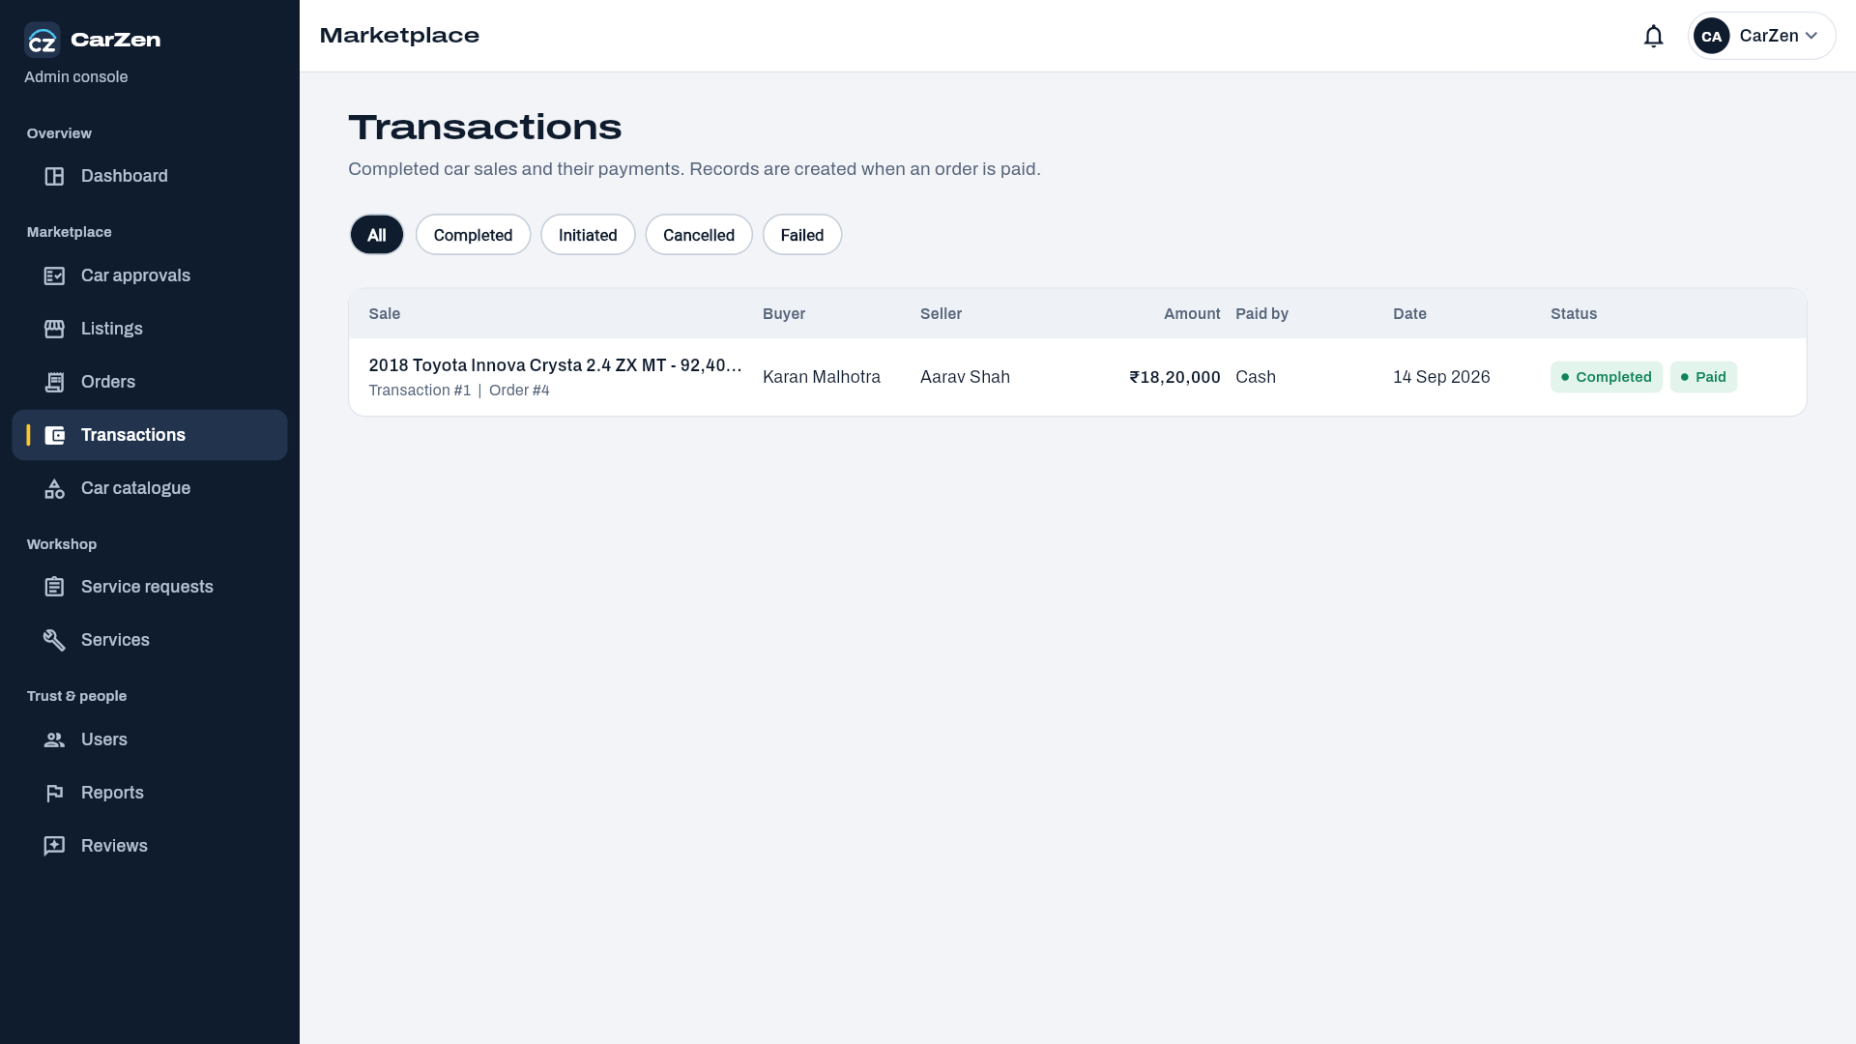
Car Catalogue Page:
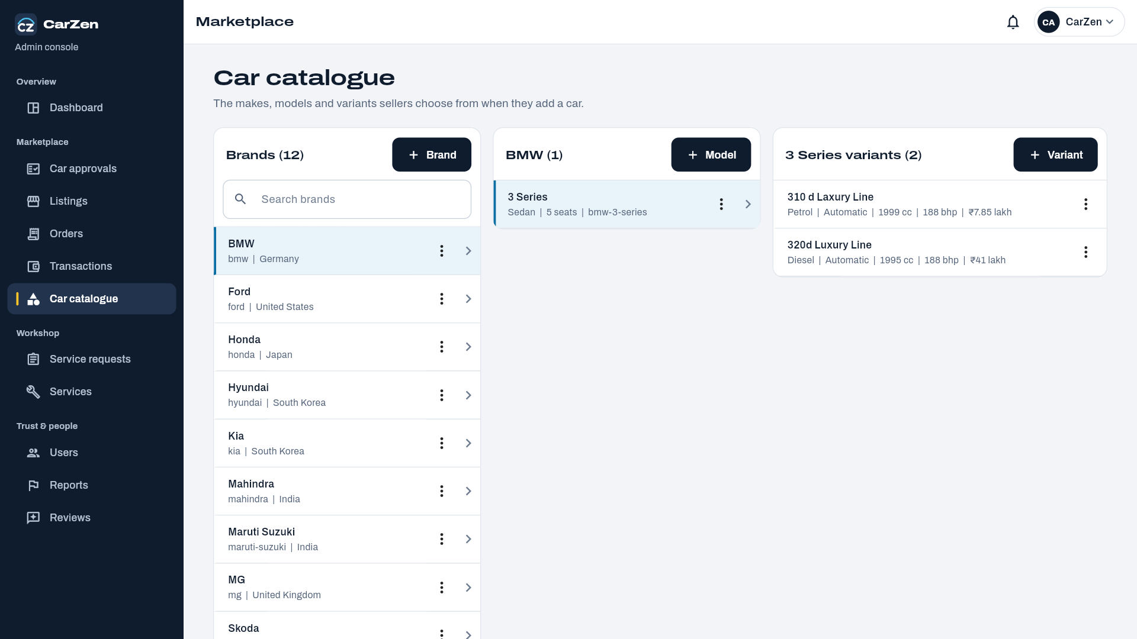
Service Catalog Page:
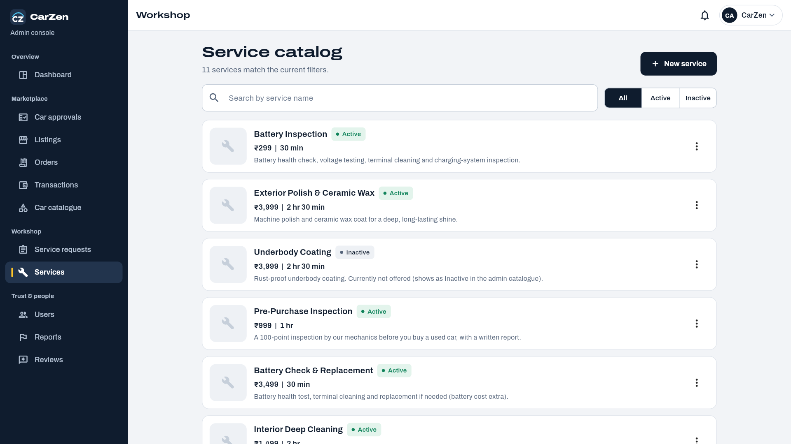
Users Page:
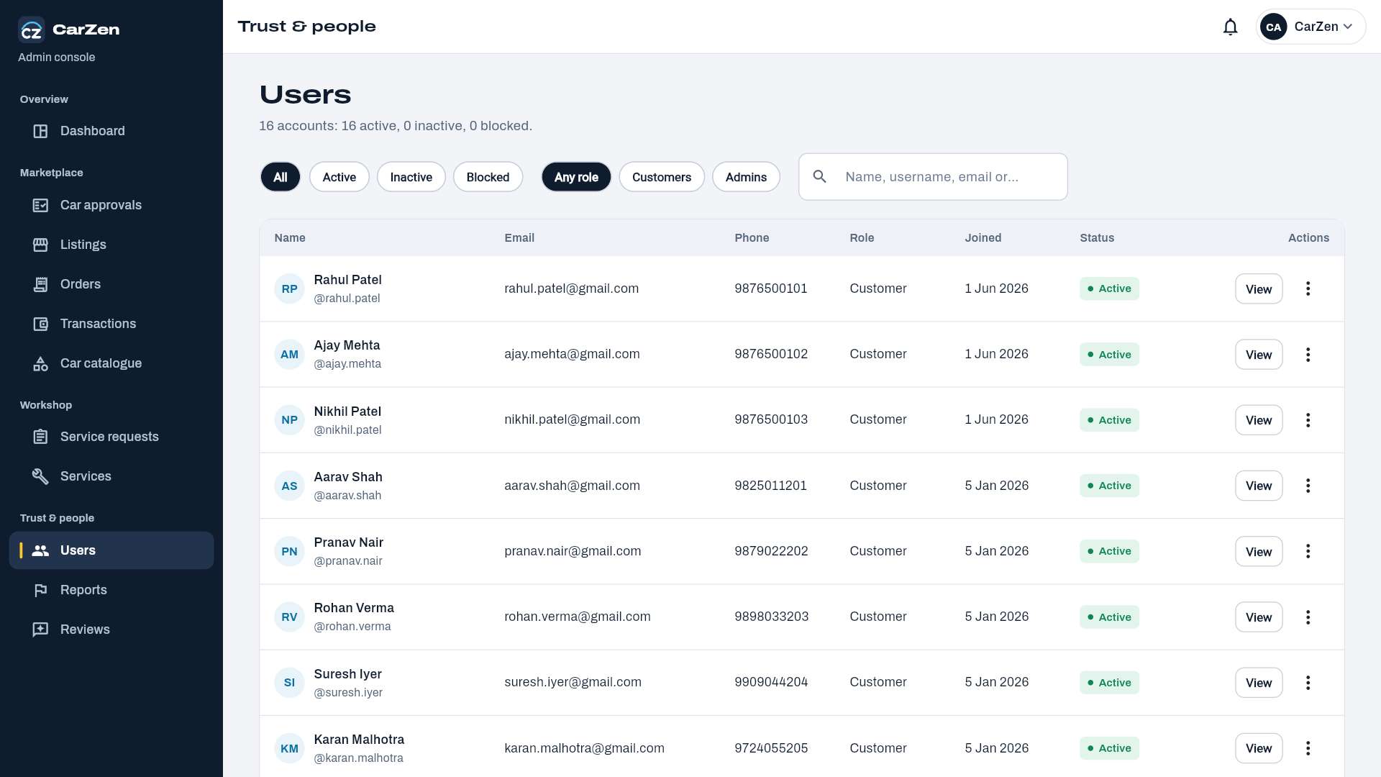
Report Page:
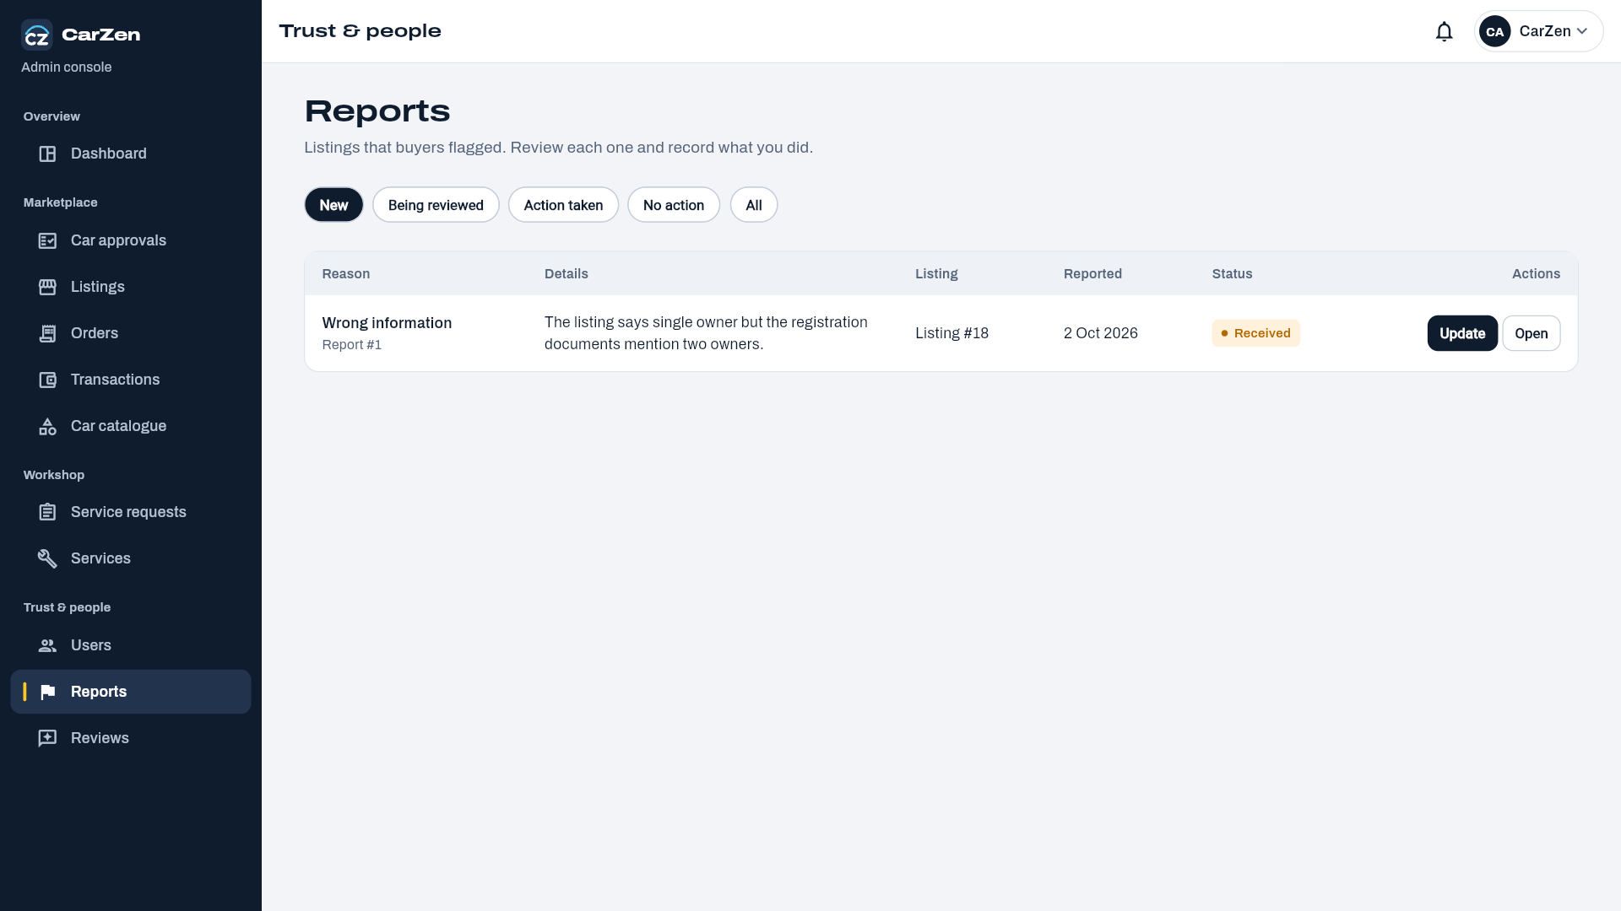
Review page:
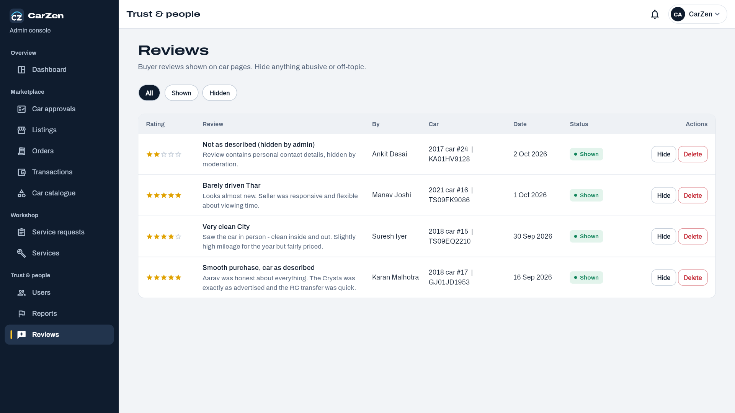
Admin Profile Page:
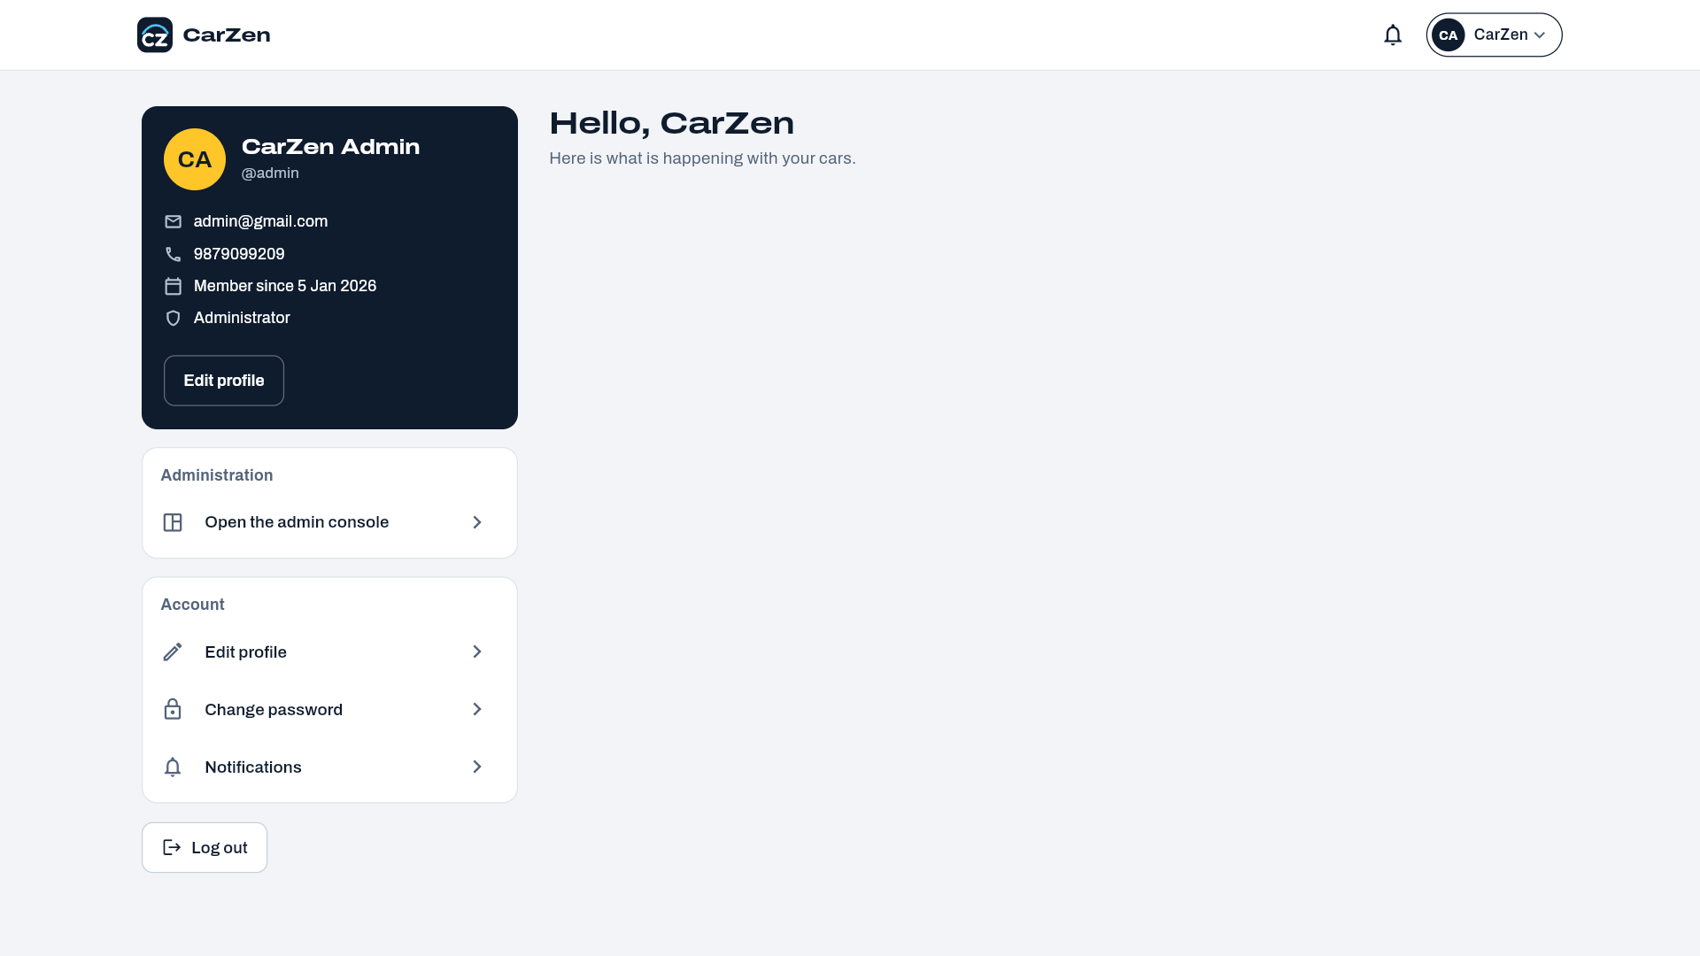
Workshop :
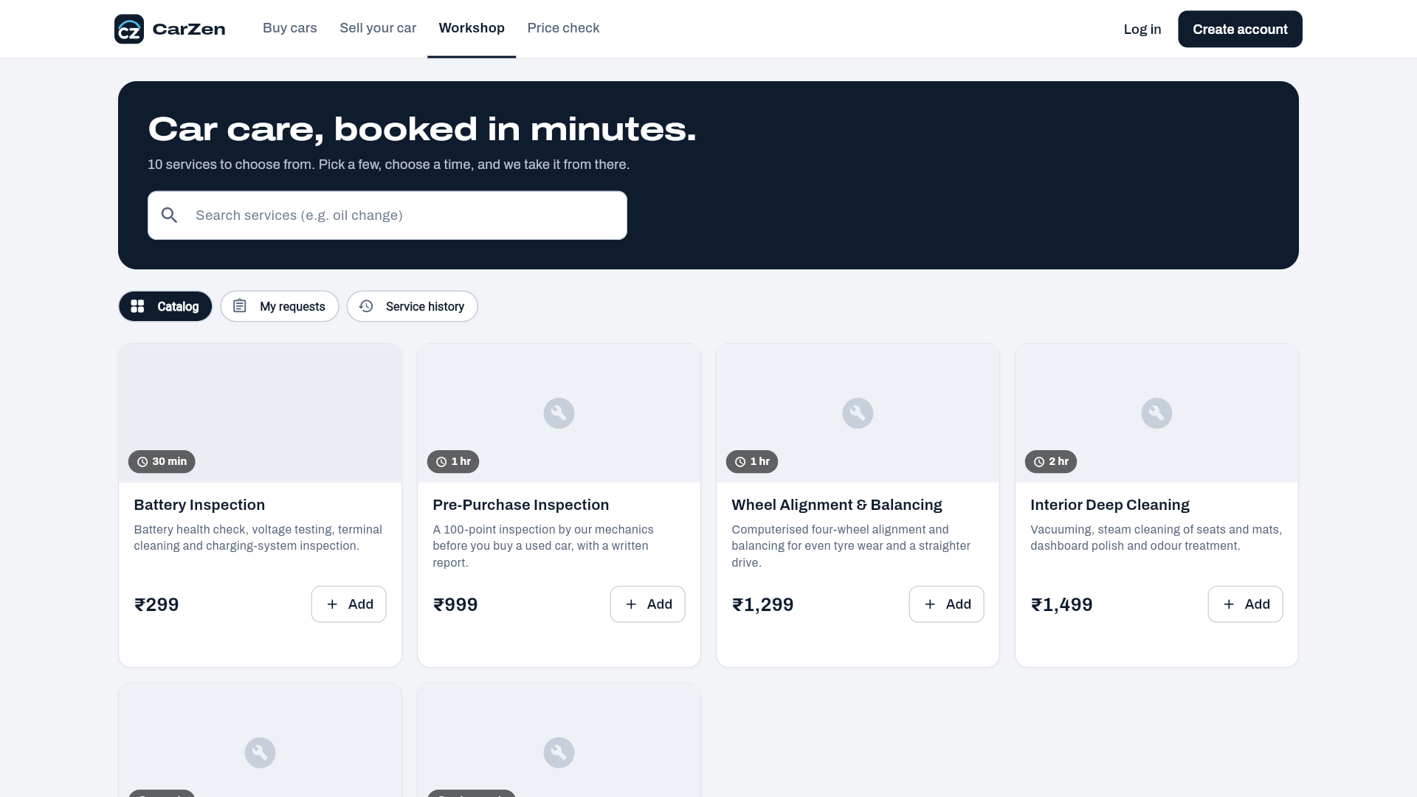

User Selling page:
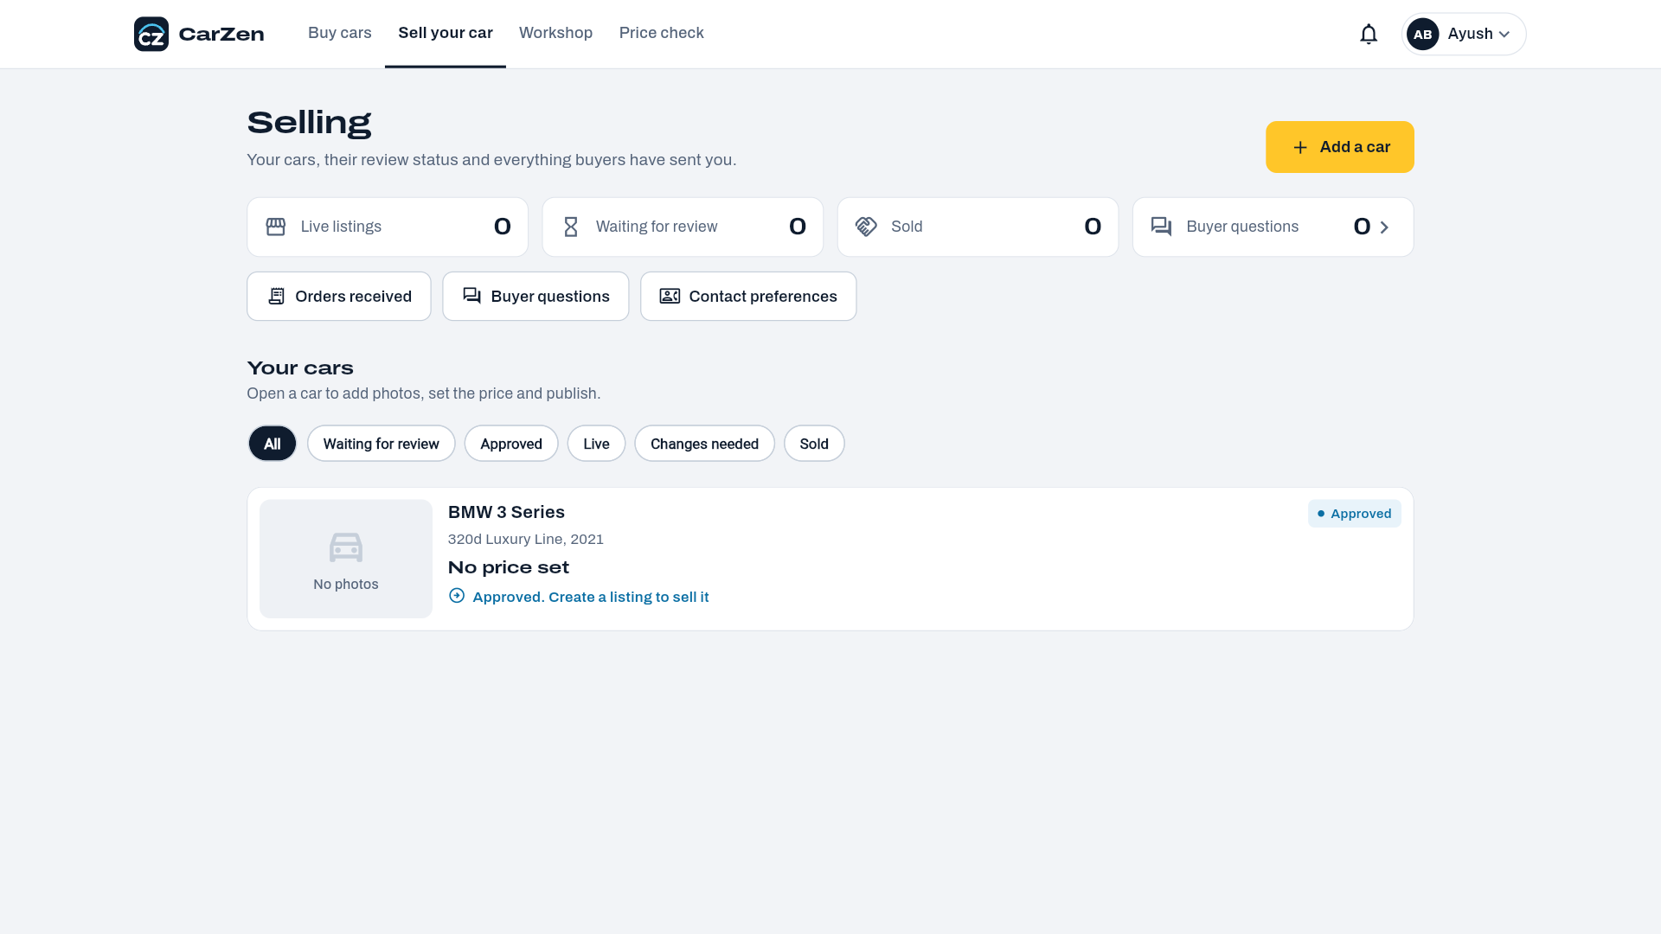

3.4 Report Design
Reports present the data stored in the CarZen MySQL database in a structured and readable form. They help buyers, sellers, car owners and the administrator review activity, take decisions and keep records. Reports are generated by FastAPI endpoints that query the database and are displayed in the Flutter application as lists, tables and summary cards. The reports designed for CarZen are listed below.
Report Name | Purpose | Main Users | Source Tables
User Report | Lists registered users with role, status and registration date. | Administrator | users
Car Inventory Report | Lists all cars with brand, model, variant, year, fuel type, mileage, city and approval/verification status. | Administrator, Seller | cars, car_brands, car_models, car_variants
Active Listings Report | Shows current listings with asking price, negotiable flag, status, views and expiry date. | Administrator, Seller, Buyer | listings, cars, users
Seller Performance Report | Shows number of listings, views, inquiries and sold cars for each seller. | Seller, Administrator | listings, inquiries, transactions
Car Approval Report | Lists cars submitted for approval with their status (pending, approved or rejected) and rejection reason. | Administrator, Seller | cars, users
Service History Report | Shows service type, date, cost and items for a car, with the related service request. | Car Owner, Buyer | service_records, service_items, service_requests
Price Prediction Report | Shows the car details entered and the predicted price, with the user's prediction history. | Buyer, Seller, Car Owner | car_price_predict
Transaction and Payment Report | Shows sale orders and transactions with amount, payment method and payment status. | Administrator, Buyer, Seller | orders, transactions, payments
Inquiry and Favourites Report | Shows inquiries received and cars saved as favourites. | Seller, Buyer | inquiries, favorites
Reviews and Reports Summary | Shows reviews submitted and complaints/reports raised against listings or cars. | Administrator | reviews, reports

Report Layout 1: Active Listings Report
Report header: CarZen logo, report title, generated date and applied filters (city, brand, price range, status). Footer: page number and total record count.
Sr. No. | Listing Title | Brand / Model | Year | Mileage (km) | Asking Price | Status | Views
1 | Well-maintained Swift VXi | Maruti / Swift | 2019 | 42,000 | Rs. 5,50,000 | Active | 128
2 | Hyundai Creta SX Diesel | Hyundai / Creta | 2018 | 61,500 | Rs. 9,25,000 | Active | 94
3 | Honda City ZX CVT | Honda / City | 2020 | 28,300 | Rs. 10,40,000 | Sold | 210

Note: the values shown are sample data to illustrate the layout.

Report Layout 2: Service History Report
Report header: car registration number, brand, model, variant and current owner name.
Service Date | Request No. | Service Type | Items / Work Done | Odometer (km) | Cost
12-Jan-2024 | SR-12 | Periodic Service | Oil change, filter replacement | 38,500 | Rs. 4,200
20-Jul-2024 | SR-18 | Repair | Brake pad replacement | 44,200 | Rs. 3,800

Footer: total number of services and total service cost.
Report Layout 3: Price Prediction Report
Field | Details
Car Details | Car name, manufacturing year, kilometres driven, fuel type, seller type, transmission, owner type, mileage, engine capacity, maximum power, seats
Predicted Price | Estimated market price returned by the XGBoost machine learning model (INR)
Prediction History | Previous predictions of the user, latest first

Report Design Standards
- Every report has a title, generation date and the filters applied.
- Tables use fixed column headings and consistent alignment: text left-aligned, numbers right-aligned.
- Prices are shown in Indian Rupees (Rs.) and dates in DD-MMM-YYYY format.
- Reports can be searched, filtered and sorted in the application; service invoices can be downloaded as PDF.
- Access to each report is limited by user role through the authentication layer.

4. Development and Implementation

4.1 Development
CarZen is developed as a cross-platform application with a Flutter frontend, a Python FastAPI backend and a MySQL database. The Flutter application communicates with the backend through REST APIs that exchange JSON data. The backend applies the business rules, accesses the database and calls the machine learning model to predict car prices.
Technology Stack
Layer | Technology | Purpose
Frontend | Flutter (Dart) | Cross-platform user interface for users (buyers, sellers, car owners) and the administrator.
Backend | Python, FastAPI, SQLAlchemy | REST APIs, validation (Pydantic), authentication and business logic.
Database | MySQL, Alembic | Relational storage of users, cars, listings, orders, payments, service and prediction data; schema migrations.
Machine Learning | Python (pandas, scikit-learn, XGBoost, joblib) | Training and use of the used-car price prediction model.
Authentication | JWT (python-jose), bcrypt (passlib) | Secure login and role-based access.
Testing | Postman, Swagger UI | Testing and verification of API endpoints.
Version Control | Git / GitHub | Source code management and team collaboration.
Payments | Razorpay | Online payment of car orders and service bills with signature verification; cash payment confirmation.
Invoices | ReportLab | Generation of service invoice PDFs.

System Architecture
The system follows a three-tier architecture. The presentation tier is the Flutter application. The application tier is the FastAPI server, which contains routers, services and the prediction component. The data tier is the MySQL database, which stores all structured data. Requests flow from Flutter to FastAPI, then to MySQL or the prediction model, and the response returns to the screen. Razorpay is used as the external payment gateway, and uploaded car images are stored in the server's uploads folder.
Module Implementation
Module | Implementation Summary
User Management | Registration (password of at least 8 characters with upper-case, lower-case, digit and special character), login, JWT access token, profile update, change password, saved addresses and contact preferences. Two roles are used: user and admin. Passwords are stored only as bcrypt hashes (password column).
Car Management | Admin manages the brand-model-variant catalogue. Users add cars with details, images (car_media) and features (car_features); every car is sent for admin approval (pending, approved or rejected). Soft delete is supported using deleted_at.
Car Buying / Search | Search public listings and filter by brand, model, variant, fuel type, transmission, city, state, price, year, mileage and condition with sorting; view car details; save favourites; send inquiries and chat with sellers; recently viewed cars.
Car Selling Module | Owners create a listing for an approved car, publish or unpublish it, update the asking price and negotiability, and track listing status and views; seller dashboard, inquiries and orders (accept, reject, update status).
Reselling Module | A listing can be of type sale or resale; owner_count and ownership_type are stored for each car so that buyers can see how many owners the car has had.
Car Service Module | Admin-managed service catalogue. Users add their car and request one or more services for a date and time; the admin accepts, schedules, starts and completes the request. Completion creates service records and items (service history) and an invoice PDF; payment is online or in cash.
Price Prediction Module | Takes car details from the user, runs the trained XGBoost model, returns the predicted price and stores the input and result in the car_price_predict table; the user can view the prediction history.
Admin Module | Approves, rejects and verifies cars; approves, rejects, suspends and removes listings; manages users (role and status), orders, transactions, service catalogue and requests, review visibility and reports; admin dashboard.
Order & Payment Module | The buyer places an order on a listing and the seller accepts or rejects it. Payment is made online through Razorpay (HMAC signature verification and webhook) or in cash confirmed by the seller or admin. After payment a transaction is recorded and the listing and car are marked sold.
Reviews, Reports & Notifications | Users rate cars (1 to 5) and report suspicious listings; the admin handles reports and review visibility; notifications are created for events such as inquiries, orders, payments and approvals.

Main API Endpoints
Method | Endpoint | Description
POST | /v1/auth/register | Register a new user
POST | /v1/auth/login | Login and receive an access token
GET | /v1/users/me | View own profile
PATCH | /v1/users/update/me | Update own profile
GET | /v1/car-brands | List car brands (similar: /v1/car-models, /v1/car-variants)
POST | /v1/cars | Add a car (sent for admin approval)
GET | /v1/cars | List own cars
PATCH | /v1/cars/{car_id} | Update own car
DELETE | /v1/cars/{car_id} | Remove own car
POST | /v1/cars/{car_id}/media | Upload car images
POST | /v1/cars/{car_id}/listing | Create a listing for a car
PATCH | /v1/cars/{car_id}/listing | Update the listing of a car
POST | /v1/cars/{car_id}/listing/publish | Publish the listing of an approved car
GET | /v1/listings | Search and filter public listings
GET | /v1/listings/{listing_id} | View listing details
POST | /v1/cars/{car_id}/favorite | Save a car as favourite
GET | /v1/users/me/favorites | View favourite cars
POST | /v1/buyer/listings/{listing_id}/inquiries | Send an inquiry to the seller
POST | /v1/inquiries/{inquiry_id}/messages | Send a message in an inquiry thread
POST | /v1/orders/listings/{listing_id} | Place an order for a listing
POST | /v1/payments | Create a payment (Razorpay or cash) for an order
POST | /v1/payments/{payment_id}/verify | Verify the Razorpay payment signature
POST | /v1/payments/{payment_id}/confirm-cash | Confirm a cash payment
GET | /v1/services | View the service catalogue
POST | /v1/service-requests | Book a service for a car
GET | /v1/services/history | View service history
POST | /v1/car-price-predict | Predict the price of a car
GET | /v1/car-price-predict | View own prediction history
POST | /v1/reviews | Submit a review
POST | /v1/reports | Report a listing or car
GET | /v1/notifications | View notifications
GET | /v1/admin/users | Admin: list users
POST | /v1/admin/cars/{car_id}/approve | Admin: approve a car
PATCH | /v1/admin/listings/{listing_id}/approve | Admin: approve a listing
GET | /v1/admin/orders | Admin: view orders
POST | /v1/admin/service-requests/{request_id}/accept | Admin: accept a service request

Machine Learning Implementation
- Dataset: Historical used-car data containing car name, year, kilometres driven, fuel type, seller type, transmission, owner type, mileage, engine capacity, maximum power, seats and selling price.
- Preprocessing: Conversion of numeric fields, creation of an age feature (age = 2026 - year), encoding of categorical fields (car name and owner type as one-hot columns) and saving the training column list (feature_columns.pkl) so that every prediction input is aligned with the training data.
- Model Training: An XGBoost regression model is trained on the prepared data and saved with joblib as car_price_model.pkl (the model name is saved in model_name.pkl).
- Integration: The saved model and column list are loaded by FastAPI. The POST /v1/car-price-predict endpoint validates the input with Pydantic, produces the prediction and stores the input and result in the database; GET /v1/car-price-predict returns the user's history. The Flutter price check screen suggests car names taken from the training data.
Implementation Environment
- Operating system: Windows 10/11.
- Tools: VS Code or Android Studio, MySQL Workbench, Postman, Git.
- Runtime: Flutter SDK, Python 3.x with FastAPI and Uvicorn, MySQL 8.0.
- Client: Android device or emulator, and web browser.

4.2 Coding Standards
Coding standards were followed so that the source code is readable, consistent and maintainable by all team members.
Area | Standard Followed
Naming (Python) | snake_case for variables, functions and files; PascalCase for classes; UPPER_CASE for constants.
Naming (Dart) | lowerCamelCase for variables and functions; UpperCamelCase for classes and widgets; snake_case for file names.
Naming (Database) | Plural snake_case table names (e.g. car_variants) and snake_case column names; id as primary key and table_id for foreign keys.
Code Style | PEP 8 for Python and the official Dart style guide for Flutter; consistent 4-space (Python) and 2-space (Dart) indentation.
Project Structure | Backend divided into api (routers), schemas, models, services and core folders, with the trained model in a model folder; Flutter divided into pages, widgets, models, services, routes, utils and config folders.
Comments and Documentation | Docstrings for functions and short comments for complex logic; FastAPI auto-generated documentation (Swagger UI) and an API documentation file for the endpoints.
Validation | Request validation using Pydantic schemas; form validation in Flutter before sending data.
Error Handling | Proper HTTP status codes and clear error messages; try/except handling around database and model calls.
Security | Password hashing (bcrypt), JWT token-based authentication, role checks, ORM/parameterised queries to avoid SQL injection, and no secrets in source code (environment variables from a .env file are used).
Reusability | Reusable widgets in Flutter and reusable service functions in the backend to avoid duplicate code.
Version Control | Meaningful commit messages, feature-wise branches and regular pushes to GitHub.

5. Testing
Testing was carried out to verify that CarZen works according to the requirements. Unit testing was done for individual functions and APIs, integration testing for communication between Flutter, FastAPI and the database, and functional testing for complete user scenarios. API endpoints were tested using Postman, Swagger UI and automated API test cases, and the user interface was tested manually on the Flutter application.

5.1 Test Cases
ID | Test Case | Input / Action | Expected Result | Status
TC01 | Register with valid details | Name, unique email, username, password | User account is created | Pass
TC02 | Register with existing email | Email already in database | Error: email already exists | Pass
TC03 | Register with empty required field | Blank email or password | Validation message is shown | Pass
TC04 | Login with valid credentials | Correct email and password | Login successful, token returned | Pass
TC05 | Login with wrong password | Valid email, wrong password | Error: invalid credentials | Pass
TC06 | Access protected page without login | No token | Access denied (401) | Pass
TC07 | Update user profile | Changed name and phone number | Profile is updated | Pass
TC08 | Admin-only access by normal user | Buyer calls admin endpoint | Access forbidden (403) | Pass
TC09 | Search cars by brand | Brand = Hyundai | Only Hyundai cars are listed | Pass
TC10 | Filter by price range and fuel type | Rs. 3-8 lakh, Petrol | Matching cars are displayed | Pass
TC11 | Search with no matching result | Unavailable brand/model | "No cars found" message | Pass
TC12 | View car details | Select a car | Complete details and images are shown | Pass
TC13 | Add car to favourites | Tap favourite icon | Car is saved in favourites list | Pass
TC14 | Send inquiry to seller | Message for a listing | Inquiry is stored and visible to seller | Pass
TC15 | Create a listing | Approved car, valid price details | Listing is created and becomes Active after publishing | Pass
TC16 | Create listing with invalid price | Negative or empty price | Validation error | Pass
TC17 | Update a listing | Change asking price | Listing is updated | Pass
TC18 | Remove a listing | Delete own listing | Listing is removed from search results | Pass
TC19 | Seller edits another seller's listing | Different seller id | Action is rejected | Pass
TC20 | Place a purchase order | Buyer selects an active listing and places an order | Order is created with Pending status | Pass
TC21 | Book a service request | Own car, service, date and time | Request is saved with Requested status | Pass
TC22 | View service history | Admin completes the request; user opens history | Completed service is shown in the history | Pass
TC23 | Predict price with valid input | Car name, year, km driven, fuel, seller type, transmission, owner, mileage, engine, power, seats | Predicted price is returned | Pass
TC24 | Predict price with missing fields | Mileage omitted | Validation error, no prediction | Pass
TC25 | Prediction result is stored | Run prediction, then open prediction history | Record is added to car_price_predict and shown in history | Pass
TC26 | Admin manages users | Block a user | User status changes and login is denied | Pass
TC27 | Admin removes reported listing | Select reported listing | Listing is removed | Pass
TC28 | Notification delivery | New inquiry received | Seller sees a notification | Pass
TC29 | Cash payment for an order | Seller accepts order; buyer chooses cash; seller confirms cash | Order is marked Paid and a transaction is recorded | Pass

Status "Pass" indicates that the test case was executed and the actual result matched the expected result. Test cases for all modules (user, authentication, car buying, selling, orders and payment, service and prediction) have been executed; the API test cases were run automatically on a test database.

6. Proposed Enhancements
The following features can be added to CarZen in future versions to make the system more useful and complete.
- Advanced Payments: Automated refunds, instalment or finance options and listing fees, in addition to the existing Razorpay online and cash payments.
- Improved Prediction Model: Retrain regularly with fresh market data, add features such as accident history, tyre condition and demand trends, and show a price range with a confidence score.
- Car Comparison with Charts: Side-by-side comparison of specifications, price and ownership cost.
- Service Reminders: Reminders for next service, insurance and RC expiry, and support for multiple workshop centres.
- Vehicle History Verification: Integration with RTO or insurance data to verify registration, VIN and ownership.
- Push Notifications: Mobile push alerts for price drops, new matching listings and inquiry replies, in addition to the existing in-app notifications.
- Recommendation System: Suggest cars based on user search, favourites and budget.
- Advanced Admin Analytics: Dashboards with sales trends, popular brands and user growth.
- iOS Release and Deployment: Publish the Flutter application on iOS and deploy the backend and web client on a cloud server.

7. Conclusion
CarZen: Car Selling, Buying, Service System provides a single platform where users can buy, sell and resell cars, manage vehicle service records and estimate the price of a car using machine learning. It addresses common problems of the existing process, namely scattered information, manual price estimation and the lack of vehicle history.
The system was analysed, designed and developed using Flutter, Python with FastAPI and MySQL. Requirement analysis, use case diagrams, a data dictionary covering the complete database, user interface design and report design have been prepared. The user and authentication, car catalogue and approval, car buying and search, car selling and listing, order and payment, service booking and history, price prediction and admin modules are implemented and tested.
The project helped the team gain practical experience in cross-platform application development, REST API design, relational database design and applying machine learning in a real application. With the proposed enhancements, CarZen can grow into a complete and reliable automobile marketplace that improves transparency between buyers and sellers.

8. Bibliography
The following books and websites were referred to during the development of this project.
- Flutter Documentation - https://docs.flutter.dev
- Dart Programming Language - https://dart.dev/guides
- FastAPI Documentation - https://fastapi.tiangolo.com
- Python Documentation - https://docs.python.org/3
- MySQL Reference Manual - https://dev.mysql.com/doc
- Pydantic Documentation - https://docs.pydantic.dev
- scikit-learn Documentation - https://scikit-learn.org/stable
- pandas Documentation - https://pandas.pydata.org/docs
- Postman Learning Center - https://learning.postman.com
- Git and GitHub Documentation - https://docs.github.com
- SQLAlchemy Documentation - https://docs.sqlalchemy.org
- XGBoost Documentation - https://xgboost.readthedocs.io
- Razorpay Documentation - https://razorpay.com/docs
- Alembic Documentation - https://alembic.sqlalchemy.org
- Roger S. Pressman, Software Engineering: A Practitioner's Approach, McGraw-Hill.
- Ian Sommerville, Software Engineering, Pearson.
- Elmasri and Navathe, Fundamentals of Database Systems, Pearson.

